Our Vision and Ethos
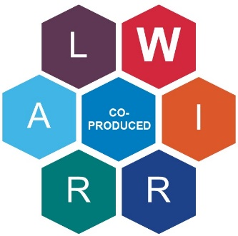
We believe that just like Special Educational Needs and Disabilities (SEND), co-production is everybody’s business. It’s a key part of SEND provision in the local area and underpinned by legislation including the Children and Families Act 2014.
With the help of children and young people, practitioners, parents and carers, we have refreshed the Wirral Co-production Charter and outlined the commitment we have all made to work together and how that will work in practice.
Whilst this has been produced primarily as our SEND Co-production Charter, we have been mindful to ensure it can be applied in a general context as well.
We believe co-production is where children, young people, parents, carers, and services work together as equals to make a change from the beginning. Being equal means that everybody’s experiences, voices and ideas have the same value.
All partners work together to identify what needs to change or be developed and how it should be done. Shared values equal better lives.
By working in a co-productive way, we are in a better position to build:
- Better understanding of the local picture
- Better understanding of what works and what doesn’t
- More effective targeting of resources
- Stronger accountability (multi-lateral)
- Increased trust
- Improved relationships with families
- Engaging, appealing and accessible services and products
- A responsive, relevant, and useful service offer
- Ownership among users to champion the services
I like it when I’m asked to get involved – I have so much to share that will help.
We can do more when we work together
Young person

Co-production Principles
The Charter helps us to address key themes that emerged from the Wirral Voices Day and conversations with our stakeholders.
The Wirral VOICES Day was commissioned by Parent Carer Participation Wirral (PCPW), the Wirral's Director of Children's Services, Wirral Clinical Commissioning Group and NHS England. The aim was to start the process of transformation - to improve the experiences of, and outcomes for, children, young people, and their families.
https://localofferwirral.org/voices-co-production-event/
By inviting young people, parents and carers as well as key practitioners from Education, Health, and Social Care, it started a dialogue that would form the foundations from which greater co-production could emerge. The themes highlighted the need to:
- Improve communication
- Improve relationships
- Build trust
Wirral SEND Partners/Services commit to addressing these themes and making co-production work well by building a suitable environment. The four cornerstones of effective co-production were produced by Genuine Partnerships and are widely accepted as key considerations when building this environment, these are –
WELCOME AND CARE
- Ensure that all voices are heard and valued
- Ensure that expectations are communicated with clarity
- Create supportive communities
- Create environments which feel happy and secure for everyone
- Enable strengths and achievements to be emphasised
VALUE AND INCLUDE
- Promote a ‘can do’ approach as the norm
- Create decision making processes which involve the people they are about or affect
- Welcome the involvement of all partners at every stage
- Respond to individual needs and changing circumstances in a creative and flexible way

COMMUNICATE
- Use written and spoken language that is clear and positive
- Use appropriate means of communications in order to ensure that everyone is included
- Agree to actions that are regularly reviewed and evaluated with all partners
WORKING IN PARTNERSHIP
- Ensure opportunities for all partners to feedback in order to improve everyone’s experience
- Co-production and participation in individual and strategic decision making is actively encouraged
- Partners work well together
- Treat everyone as an equal partner and value their contribution
We have taken the four cornerstones as foundations for the principles behind the WIRRAL approach. Remember WIRRAL when you co-produce:
Working Together
- Communicate well
- Work in partnership
- Create strong partnerships so everyone can:
  - Feel valued and included
  - Learn from each other
  - Be honest and transparent
  - Take responsibility for how we work together
  - Have a ‘can do’ approach
Inclusive
  - Respect everyone’s voice and views, all partners are equal in value
  - Create a welcoming environment
Responsible
  - Behave considerately
  - Represent your area of SEND expertise
Respectful
  - Be open to listening to others’ opinions

Ambitious
  - Think beyond business as usual
  - Aim high for the very best outcomes possible
Lived experiences
  - Learn from those with lived experiences to share
  - Stay grounded to the reality of Wirral people, their views and lived experiences
  - Improve the lived experience
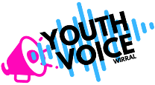
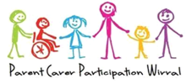

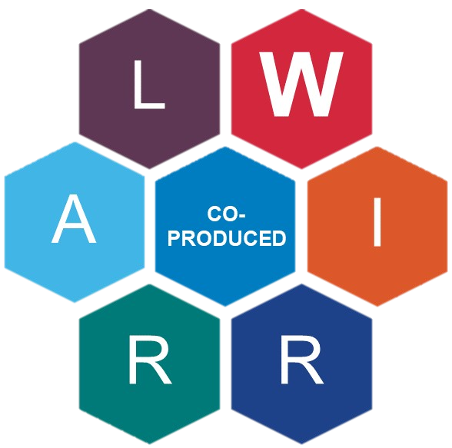
Only when these principles are met, and signed off by key stakeholder groups, will a document or project be truly co-produced and where you will see our co-production kite mark:

Steps to Effective Co-production
Together with young people, parents, carers, and a range of services we have outlined the key steps to effective co-production and key considerations below. By using the NAOMIE good practice framework which sets out every stage a project needs to go through, we can break down the planning phase into smaller chunks.
Depending on the task and situation, some steps may take priority over others, but these points serve as key considerations during the co-production process.
NEED | Why am I engaging with this person/people? What is in this process for me and for them?
AIM | Establish what it is we are going to be working to achieve together
OBJECTIVE/OUTCOME | Are we all clear on what we are trying to achieve, and do we all agree?
METHOD | How we are going to do this together effectively.
IMPLEMENTATION | Putting the plan into action.
EVALUATION | Did it go well for everyone involved? Can we improve the way we do things next time?

Other useful considerations include:
LEVEL
Agreeing the ‘level’ of working together (co-production/co-design/consultation) at the start of a project and the reason for this
PARAMETERS
Identify any existing barriers (e.g. timescales, block contracts)
STAKEHOLDERS
Agreeing the appropriate stakeholders (consider stakeholder capacity and involve everyone from the start where possible)

RESPONSIBILITY
Agreeing where responsibility sits and accountability mechanisms
FEEDBACK
Agreeing how feedback will be collected and when
COMMUNICATION
Agreeing communication methods and formats (who needs to know what and how?)
UPDATES
Agreeing the schedule for updates and reviews after completion

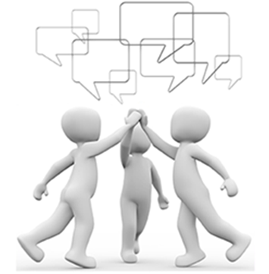
Reviewing Co-production
We believe it is important to have an ongoing review of co-production in order to reflect, improve and remain ambitious. Key questions we will consider include:
WHO WAS INVOLVED?
- Were the right people involved? Was anyone missing?
- Did key stakeholders engage and were they involved from the beginning?
DID EVERYONE FEEL WELCOMED, VALUED, AND INCLUDED?
- How was everyone included?
- Did the experts by experience feel their involvement was valued?
- Was the venue/date/time of meetings accessible?
- Did the Chair effectively include everyone?
WAS COMMUNICATION CLEAR THROUGHOUT ENGAGEMENT?
- Was communication clear, accessible and in an easy read format?
- Were minutes/agenda items given well in advance of meetings?
- Was information filtered down to all who needed to know?
WERE ACTIONS CLEAR AND FOLLOWED THROUGH?
- How were the actions clear?
- Were there clear timescales and SMART targets?
DID EVERYONE UNDERSTAND THE DECISIONS THAT WERE MADE, AND HOW THEIR INPUT SHAPED THEM?
- Was the group kept up to date/involved in the whole process?
- Has the feedback been collected from the project group?
- Was there a post-decision debrief with all stakeholders?
- Were the objectives achieved in the agreed timescales?
- Was decision making equal?
OTHER
- Have the principles of working together been followed?
- Were there any unintended consequences/benefits of working together?
- Was there monitoring at the beginning, middle and end of the project

Understanding that Co-production Isn’t Always Appropriate

We can work together in different ways: co-production, co-design and consultation.
Co-production is always our ambition, but we recognise that there is a time and a place for co-design and consultation. All of these ways of working must include children and young people and/or parents and carers, as appropriate.
CO-PRODUCTION is children, young people, parents, carers, and services working together as equals to make a change.
Being equal means that everybody’s experiences, voices and ideas have the same value.
Co-production happens when all partners work together to identify what needs to change or be developed and how it should be done.
CO-DESIGN is when one or some partners have identified that something needs to change or be developed, and they work with all partners to decide how to do it.
CONSULTATION is when one or some partners have identified that something needs to change or be developed and they have a plan for how to do it, but they work with other partners to check that the plan is a good idea and is likely to make a difference. They make changes to the plan in response to what other partners tell them.
COMMUNICATION underpins each approach and is key to the successful outcome of the task.
In all ways of working, all partners should be involved in checking that the change made a difference.
CO-DESIGN
CONSULTATION
CO-PRODUCTION

COMMUNICATION

Recent Work – What Does it Mean in Practice?

Case Study 1: Co-production

PROJECT: Wirral Health Passports
SUMMARY OF THE PROJECT:
Health Passports have been used in Wirral for some time, to share information about an individual’s health, wellbeing, and communication. However, parents and carers had given feedback that accessing Health services was challenging. During conversations between children, young people, parents and carers, practitioners, and local leaders, it emerged that improving Health Passports would be a way to make progress.
At every stage of the project, the representatives from the following groups were involved:
- Young people
- Parent and/or carer
- Practitioners
- Local authority service managers
- Local charities
- Multi-cultural organisations
- Primary care health
- NHS Trust
Everybody included was welcomed, with opinions, views and ideas considered and shared throughout. People involved in the meetings had a range of different needs and communication styles, and representatives from communities who are not often involved in this kind of work brought opinions from their members.
The Health Passport for children and young people in Wirral was launched on 29th November 2021. There is a high-quality hard copy form as well as an editable electronic version.
More information can be found here:
https://localofferwirral.org/health-passport-launch/

ELEMENTS OF CO-PRODUCTION:
- Challenge was identified by listening to families
- Solution was identified between a wide range of local stakeholders
- Engagement from children, young people and families throughout
- Input from less heard groups, with equal weight given to all voices
- Document was developed together
I’ve learned a lot and enjoyed being involved from the start. It’s fun to co-produce
Project member

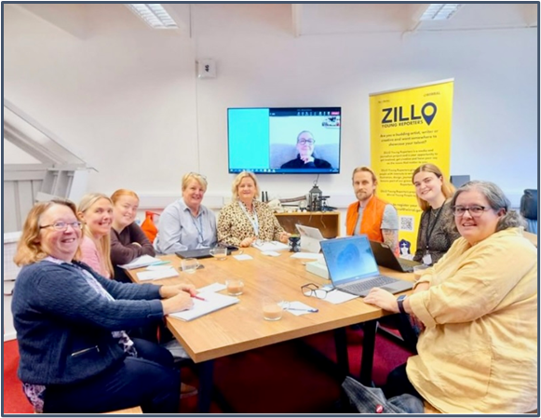
I benefitted as I got to see what other professionals do within their job and how big of an impact this passport has
SEND Practitioner

Recent Work – What Does it Mean in Practice?

Case Study 2: Co-design

PROJECT: Wirral Key Worker Team

SUMMARY OF THE PROJECT:
The Key Worker role was identified as a key post to support young people with learning disabilities and/or autism and their families through the journey of services. This was outlined as a commitment in the long-term plan of the NHS. There is an expectation that all areas will have Key Workers by 2023/24. Wirral were invited to apply to be an ‘early adopter’, along with other areas. This work was led by the Council for Disabled Children.
A task and finish project group was set up including representation from a wide range of stakeholders, including young people, parents and carers, commissioners, practitioners, local authority leaders and staff. This group discussed the main findings of the national Key Worker work in order to identify the best model for Wirral.
Participants were welcomed, with opinions, views and ideas considered and shared throughout; all had a range of different needs and communication styles, and representatives from communities often not involved in this kind of work brought opinions from their members.
Members of the task and finish group then worked together to:
- Develop job descriptions and job recruitment adverts
- Shortlist candidates
- Develop and compile the interview process, including a young people’s panel, a parent and carers’ panel, and a formal panel
- All panels had equal weighting in the interview outcomes

ELEMENTS OF CO-DESIGN:
- Initiated by an external partner
- Guidance and broad expectations in place from the start
- Local approach and implementation plan was developed by a wide range of local stakeholders
- Wide range of local stakeholders involved in interview panels, with equal weight given to all voices

Recent Work – What Does it Mean in Practice?

Case Study 3: Consultation

PROJECT: Designated Schools Grant Management Plan

SUMMARY OF THE PROJECT:

The local authority is required by the Department for Education to have a Designated Schools Grant (DSG) Management Plan to help manage finances related to SEND. The local authority commissioned an experienced Strategic Adviser to lead this piece of work.

The Strategic Adviser brought together a wide range of stakeholders to plan how communication and participation would take place during the project. This included multiple local authority leaders, education leaders, parent and carer groups, SENCo Boards, children and young people’s groups and voluntary sector organisations.

The Strategic Adviser then undertook a review of the DSG, which included inviting the full range of stakeholders to share their views on what was working well locally and what could be improved or changed. The Strategic Adviser then used these views, along with other findings from the review, to develop a draft Action Plan. This was then further developed with the stakeholders before being shared more widely.

The Department for Education approved and signed off the DSG Management Plan.

ELEMENTS OF CONSULTATION:
- Initiated by an external partner
- Expectations and parameters in place from the very start
- Communication and engagement processes developed with stakeholders
- Views sought from a range of stakeholders, brought together with other data
- Draft plan developed by Strategic Adviser based on findings, then developed further with stakeholders

