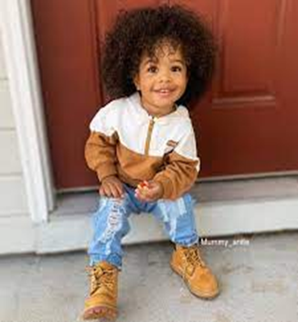

I have an excellent sense of humour.

I am keen to learn new things and ask questions.

I am very affectionate.

What people like and admire about me…

How best to support me…

Photo of Child

My One Page Profile

What’s important to me…

It is important to me that I feel secure by having the consistency of familiar people and knowing what my day will look like.

I enjoy an active learning style and need to be moving.

I need the adults around me to react consistently in response to all my behaviours. I like it when people tell me what I am doing well.

I like having things to hold and fiddle with when in group situations.

**Name Yusef**

**DoB: 2/4/19**

**Date: 21/4/22**

* My keyworker to greet me when I arrive each morning.
* Keep to the routine that is on my visual timetable.
* Help me to recognise my feelings (relating it to ‘The Colour Monster’ book) and provide me with strategies for how I am feeling (Zones of Regulation)
* Model how to play appropriately with others.
* Reassure me that my Grandma will pick me up at home time.
* Provide me with special time each day with my key person.
* During carpet times allow me to have fiddle toys.
* During mealtimes allow me to have an activity at the table to support me to sit longer.