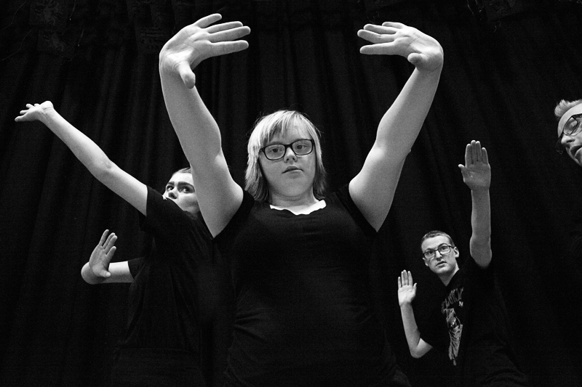

Participation & Engagement for Youth

SEND Report 2017-2021
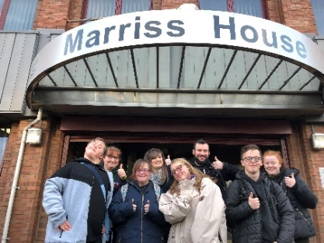
SEPTEMBER 2021

Creative Youth Development
Youth Matters
Wirral Children & Young Peoples Department
Authored by: Seline Wakerley – Team Leader
Participation & Engagement

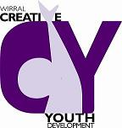

The Development
How it began…

Creative Youth Development facilitates the Youth Voice Group which acts as an overarching mechanism for young people’s engagement and offers young people an opportunity to build skills in debating, citizenship, political education, peer education training and conference planning. CYD also offers a range of inclusive and specific projects for young people with disabilities based at Pilgrim Street Arts Centre. This process was officially started when Seline Wakerley took the role on in late 2018.
CYDT has always put the young persons’ voice first and peer education has been done by CYDT for over 10yrs.
During this time, through conversations with young people with disabilities, we learnt that they also would like to be peer educators and have a voice group for SEND. Because of the differing skills, learning needs and comprehension abilities, it was agreed around 2014 that we run a SEND Peer Education Youth Voice group at Pilgrim Street facilitated by the Peer Educators from CYD. The group met once a month on Tuesday evening with Seline Wakerley and Claire Parr.
The delivery and method would be done through creative physical and visual training which would help the young people develop their peer education skills, but also to find a voice. They had their first ‘event’ at the Youth Voice Conference in 2016. Helping in workshop delivery to other young people.

This was when Natalie Johnson made contact with me (2016). Natalie was working for Community Action Wirral as Development Officer and Children & Young People's Lead. In this role she was tasked to set up a youth participation group up who have SEND needs. This was a 6-month commissioned role which finished in October 2016. The development of a SEND YVG is so that the groups views and experiences reforms to help shape the Wirral's Local Offer (www.localofferwirral.org) would be listened to. The idea of the group is that the feedback gathered will be used and directly influence commissioning of services on Wirral.

As Creative Youth Development Team has a long history of working with vulnerable young people with SEND needs and that we also lead upon the Wirral Youth Voice Group, Natalie wondered if we could help support her in the creation and set up of the group. I met with Natalie to discuss how we could develop the group. I discussed that at CYDT we have a large disabled membership that attend a dance/voice group on a Tuesday evening and that maybe we could meet with the group and their parents one Tuesday evening to discuss the idea of formalizing the SEND YVG group and its creation.

I discussed that we have a group of peer educators who have disabilities and that these young people would help support this process. Natalie stated she would like a young person with disabilities to chair the group. This was a great opportunity for a young man who is registered blind and had been part of the Youth Voice Group for the past year, and part of CYDT since 12yrs of age. This young man gained many skills through being part of the Youth Voice Group and has a passion for disabled young people to have their say on things that affect them. I spoke with the young man who was excited and delighted to have an opportunity to work on this project and help guide the adult process. I met with him to discuss the meeting and his role. We discussed a layout for the workshop and a date. The date was the 28^{th of} June and the evening would run from 6-7.30pm.

The first meeting went very well. Many attended and the disabled peer educators helped, created and worked on the question theme with the SEND YVG members. The parents were really pleased that they were having a meeting where they and their wards could look at issues that affect young people with Special Educational Needs and Disabilities. The young people and adults were able to feedback their thoughts through performance arts and discussion.

The young man chaired the adults group process and was able to explain how a Youth Voice Group process works and that he was in place to make sure that the parents’ concerns and ideas would be heard and match them with the children’s and young people’s feedback.

The plan for the next SEND YVG was that the SEND YVG will meet the current Youth Voice Group. The current Youth Voice Group will attend and support the process as part of a meet and greet activity and to make sure that the current Youth Voice Group are aware that they will be working with this group in helping them to gain a voice within Wirral.
The next theme for the SEND YVG will be looking at what is in the local area of Wirral. Linking the knowledge of Wirral activities, the group’s children and adults already attend. Therefore, helping develop the timetable for SEND young people to access on the new ‘Local Offer’ website. This work was then presented in a conference in October 2016. Which was attended by many professionals, parents, and carers.

Natalie left in October and Sally Tittle started the post and in early 2017. Sally & I met to see what the young people wanted to do about the group. The young people wanted it to continue, so they would have a monthly space where they could explore local SEND issues and support Sally in creating a good ‘local offer’ process and developed a conference for professionals and organisations in January 2018. Below is the report from this process.
The work developed relies on the relationship and commitment between myself, and was further developed when in 2018 when my role changed to ‘Participation and Engagement Team Leader’ for Wirral Youth Matters and Sally as the Communications Officer for Local Offer Wirral. Through our links and connections, through engaging and raising the group’s aspirations and voices at meetings and events, whilst promoting and supporting the young people to engage with professionals and empower them to be seen.

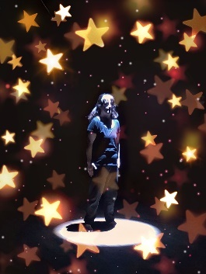

The Approach
The first SEND Youth Voice Conference 2018

It was agreed to organise a launch event at Pilgrim Street facilitated by the Youth Voice Group and Peer Educators from CYD involved in this area of work. The group continued meeting once a month on Tuesday evenings. The work is creatively hosted and consistent in attendance of leaders and young people. Creating a positive working process for all.

A member of the Youth Voice Group who is visually impaired agreed to chair the launch meeting which was well attended by young people with disabilities. Based on decisions made at the launch, the SEND Youth Voice Group would continue to meet on a monthly basis at Pilgrim Street. The young people and children would use performing arts as a tool and a way to understand issues that they want to raise and challenge. The arts approach helps the young people to see, engage and visualise the world in their way. It also helps them to understand the barriers and difficulties around them. Using dance, drama, physical theatre, drawing and imagery we have been able to develop their voice and opinions around issues that they would normally never be asked about, or judged to be ‘unable’ to understand.

It was decided that the adult’s/parent/carer voice part of the process to be put on hold in regard to them being in attendance, in the room with the Youth Voice Group. This was because the adults have a forum to raise their issues as parents already. So, the SEND YVG thought they needed a space just for their voice with independent supportive adults. They wanted it to be about them and a space for them to raise their issues in their way and about their feelings without having to feel worried or awkward about stating their opinions.
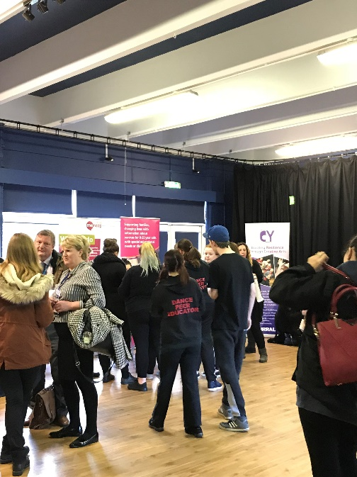

The SEND Youth Voice Conference theme was decided to be used to highlight issues that the group identified as being concerns for disabled young people in Wirral. This would be used as a starting point to give SEND young people a platform in Wirral to engage with services and organisations that work with and for them. The Wirral’s first SEND Youth Conference was held in January 2018. The group was split between under 19’s and over 19’s. The issues that were common across these age groups were -

Under 19’s | Over 19’s
Independence – skills for their future, looking after myself, understanding money | Independence – skills for the future and jobs, looking after myself, understanding finance.
Safety – stranger danger, communication, anti-social behaviours, mate crime | Safety – cyber safety, anti-social behaviours, club life/parties, mate crime.
Positive relationships – friends, family, partners | Positive relationships - friends, work mates, partners
Better engagement - how can you understand us better? | Better engagement - how can you understand us better?

What the young people told us

The group fed back their frustrations that adults around them are always spoken to first and make the decisions for them. They understood at times this may be needed. But they felt that this was now a consistent process that happens on them. They feel then they must go along with decisions and activities being ‘agreed’ to, instead of being consulted.

They also fed back that they are not seen first. They are seen as SEND young people to be worked ‘upon’, when they want to be seen as any other young person, as an individual with thoughts, feelings, hopes and dreams, with aspirations and an opinion. They admitted that they may struggle with understanding, but services and organisations should have in place better tools and methods to help them have THEIR voice heard.

They stated that when their voice is not heard, they have to do things that the adults decide is good for them, rather than feeling they can challenge this. This can leave them feeling low and not wanting to engage.

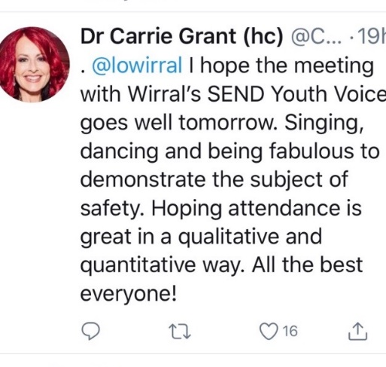
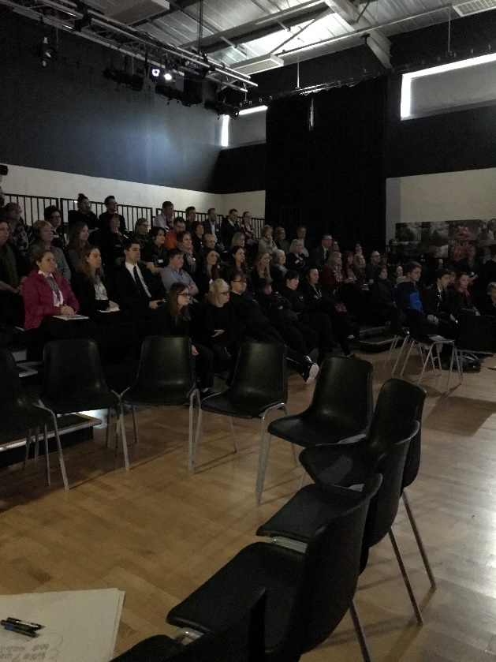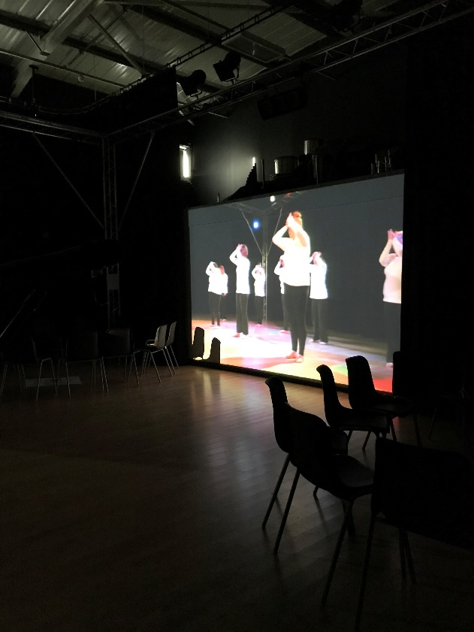

They also felt that their hopes, dreams and aspirations are limited by how parents, carers, services, organisations and businesses stereotype them. The opportunities they can access are limited, and sometimes if opportunities are offered, they are delivered in a way that has low expectations for them instead of encouraging the best from them.

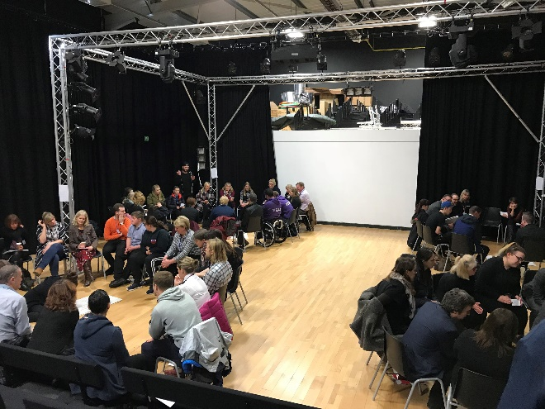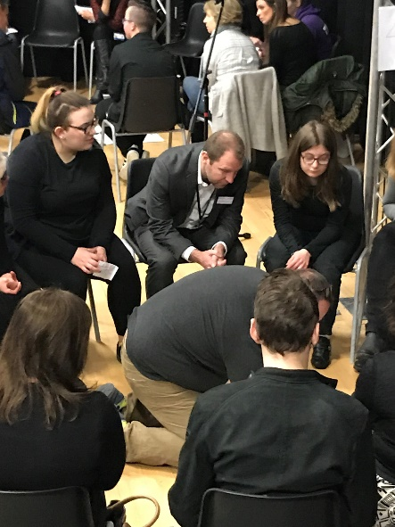

Following on from the successful SEND YVG Conference 2018 and the realisation by many attendees that disabled young people should be consulted with directly, and that they are aware and are able to highlight their own needs at times, they supported this approach.

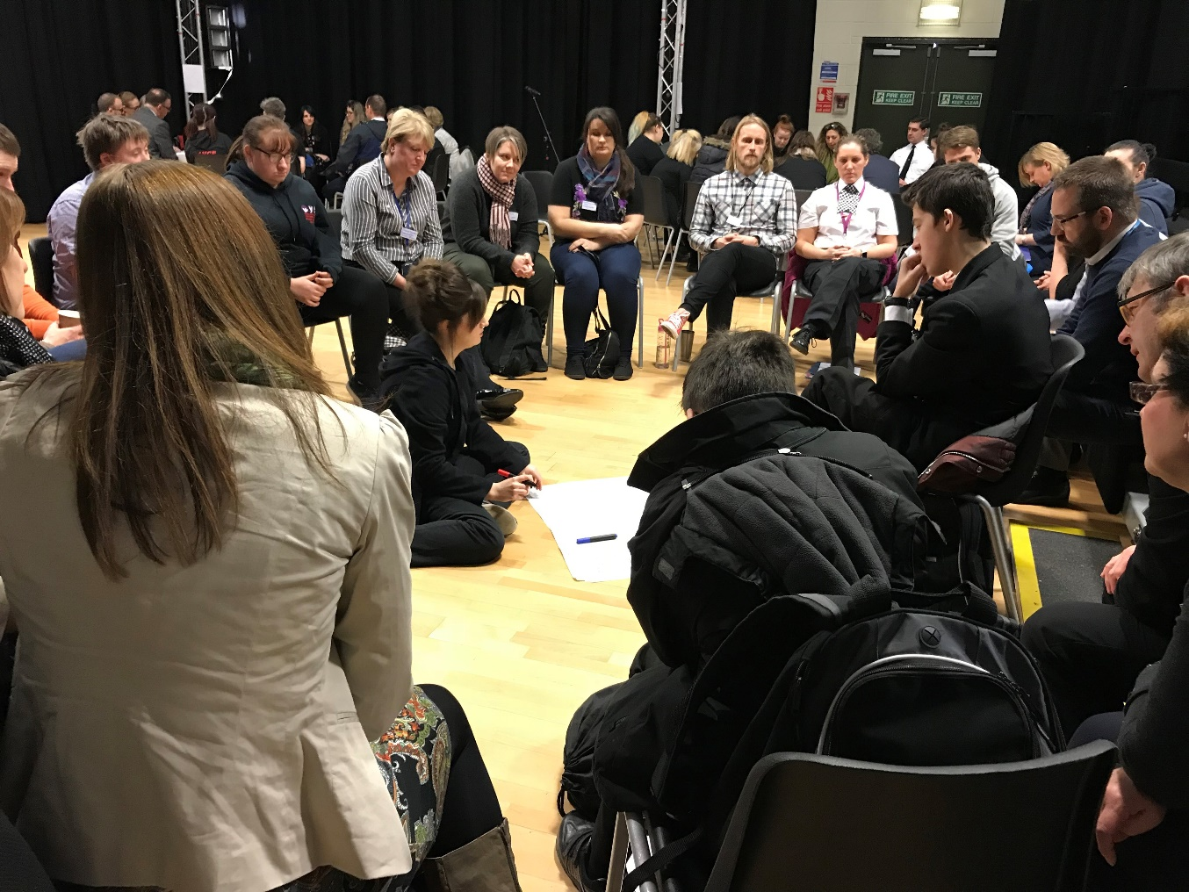

Next steps and work the group achieved in 2017-18

The group planned an event which brings together service providers, practitioners, council officers and businesses to explore what can be done to improve the lives of children and young people with disabilities in Wirral. Representatives from the group are also involved in the Youth Reference Group working alongside the Ofsted Improvement Board to ensure that children and young people’s views are heard and acted upon within the improvement action plan.

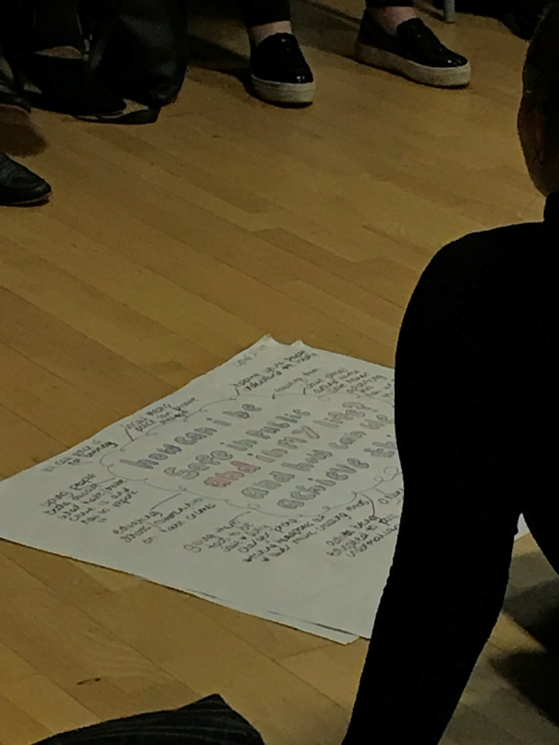

Work done by SEND YVG 2017-18

- Helping to devise, develop, host, perform and facilitating the Youth Voice Conference ‘Mental Health in Education’ 2017. Working with CAMHS to raise awareness of their peer education school programme.
- Helping to devise, develop and host the Youth Parliament ‘Mental Health in Education’ 2017. Including the first disability-based motion from a disability group.
- OFSTED process – members of the SEND youth voice group have been working with the Ofsted Reference group once a month, in supporting other young people to have their say. (Ongoing monthly meetings)
They have worked on –
    - Giving a voice in regards the service a child in care receives and how this could be improved.
    - Devising the idea of the resilience and leadership film for training staff.
    - Making the Ofsted 5 Improvement points into 21 child friendly points.
    - Presented to the official Ofsted Reference group their work on the developing the 21 points to be child friendly and why they did this.
    - Ran a workshop for the Corporate Parent Group about which 21 points their department cover.
- Leadership and Resilience film –SEND Youth Voice group worked with other young people from Looked after children group and disabled groups to have their say on the film regarding leadership and resilience. (Summer 2017)
- SEND YVG took part in the commissioning of Short Breaks work by taking part in a workshop, ran by organisations that were applying to be funded. Feeding back their thoughts and opinions. (Spring 2017)
- Taking part in Young Inspectors training. (Summer 2017)
- Helping the running of the Ofsted Reference Group Primary survey with looked after children and junior provision on a Saturday (Summer 2017)
- Attending the Wirral Chamber of Commerce – Sheds Launch, young entrepreneurs set up.
- Attending Wirral 2020 event meetings – with councillors, services and companies.
- SEND YVG helping others to Vote in Make Your Mark election at CYDT
- Creation of a dance film called ‘Glass Ceilings’ which the young people made in response to their feelings about how they feel in regard to the world around them. That they are judged and stereotyped. That they are seen as SEND first instead of young people with passions, aspirations and a voice.
- SEND YVG in developed an idea of creating an event with CYD and Local Offer worker Sally Tittle in regard to looking at what issues disabled young people in Wirral face, across the age ranges of 0-19yrs and 19yrs upwards, delivered in January 2018, inviting all services and organisations that work with disabled young people on Wirral.
- Being part of consultation meetings in regard to the Wirral Future in Minds process for CAMHS and Education.
- Being part of consultation in regard to the CCG’s Urgent Care Transformation programme. This is looking at first line services in NHS access.

Work done by SEND Youth Voice Group 2019-2020

- CAMHS launch of the Birch Centre for young people’s Mental Health. They lead as peer educators a flash mob at the launch in March 2019.
- Taking part and hosting as Peer educators the ‘Voices’ Co Production event in March 2019 working with educational organisations, social care and health, plus parenting groups. Working with professionals from other parts of the country.
- Transition to Adulthood event – with SEND YVG delivering and hosting the event, discussing the issues of transition into adult lives for SEND Young People. This was part of a voice process for Children, carers, adults and professionals. Crossing the Social, Health and Educational areas.
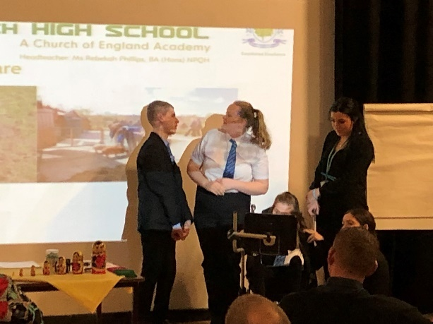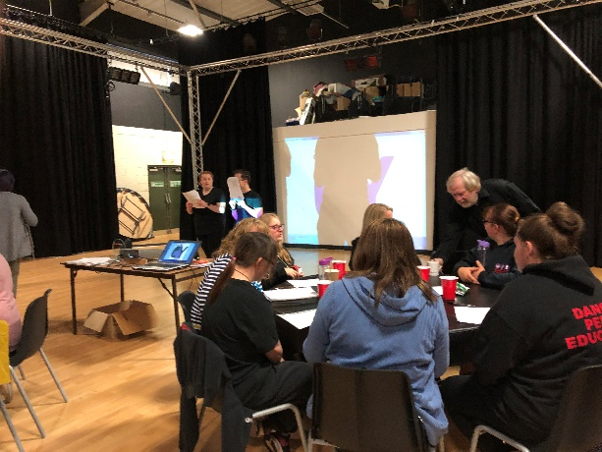
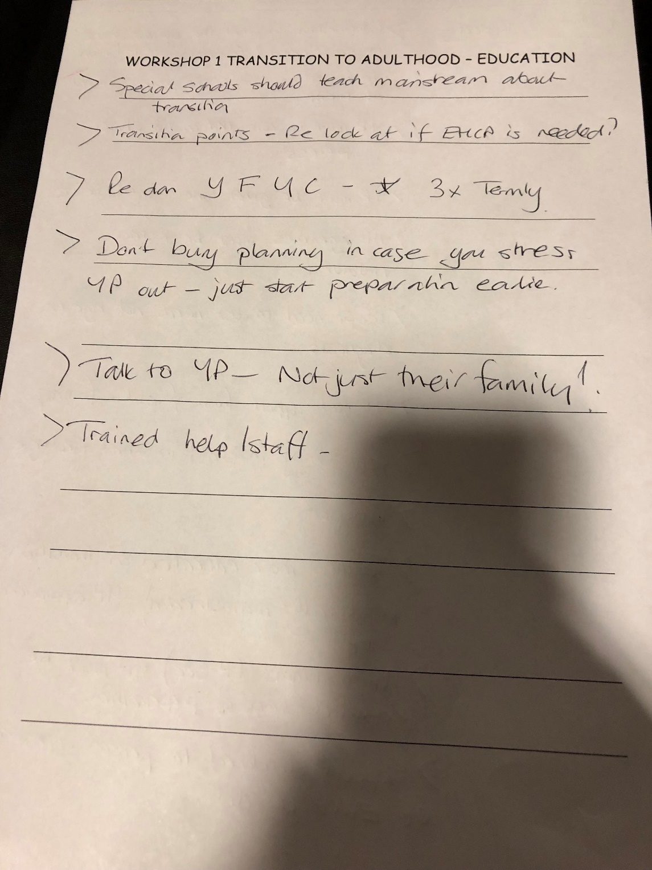
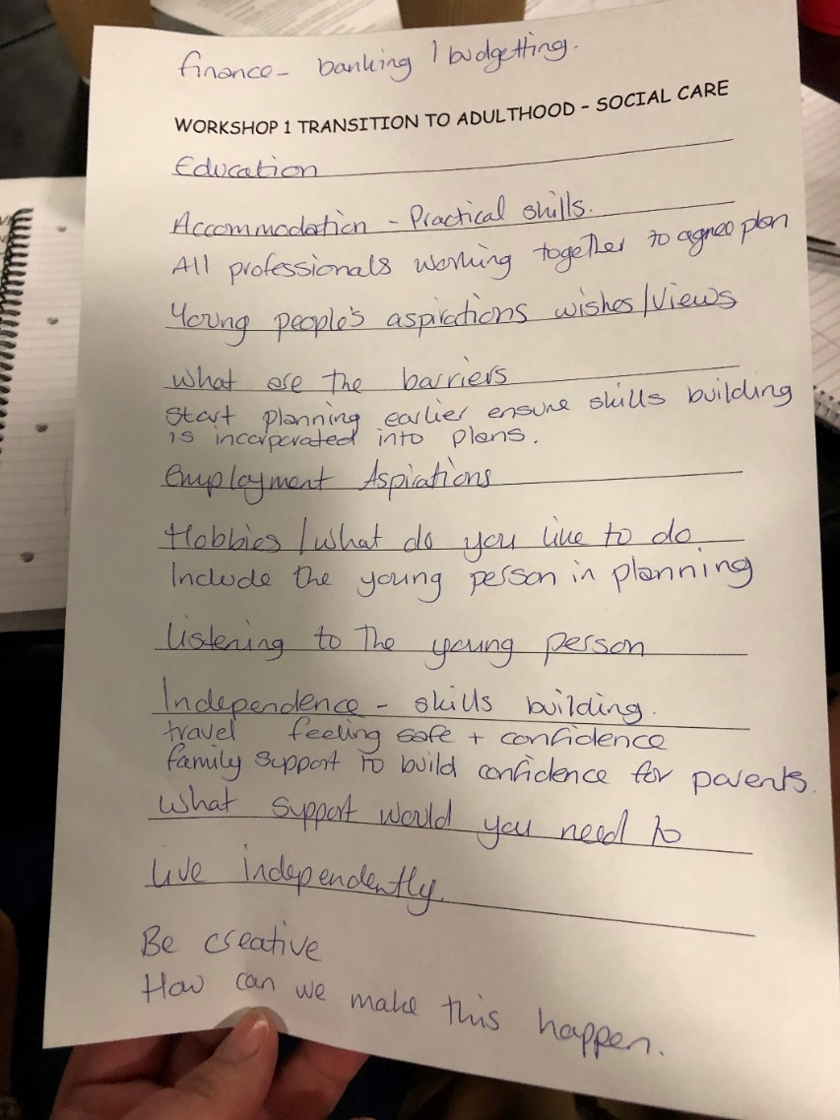

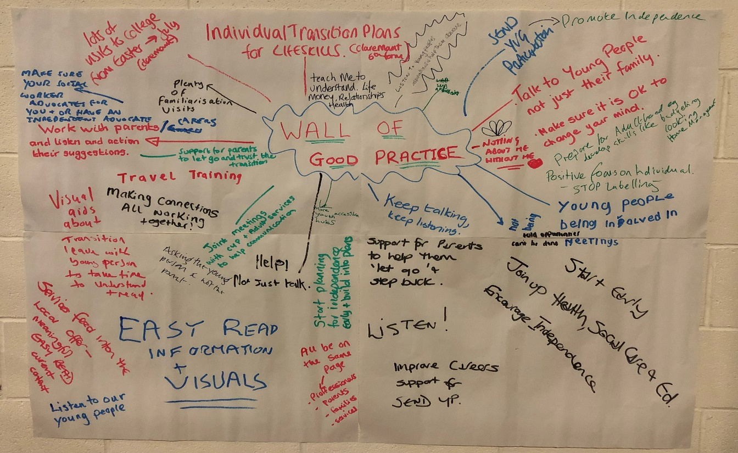

- Delivery of Young Mental Health Inspectors visits in a primary school in April 2019 and secondary school in May 2019. This was developed between CAMHS and the Wirral Youth Voice groups. It was based upon questionnaires around ADHD and mental health rights for young people. The groups developed a set of marking questions and criteria around a young person’s mental health. Once developed a pilot project was developed and delivered. This was successful and the process was to be developed and funded before COVID19 happened. This has been on hold awaiting return to normal.
- Taking part in helping with the Short Breaks Survey for young people for Sarah Towey Wirral Business analyst June 2019. This was asking young people their views on their youth offer and also short breaks as a service offer.
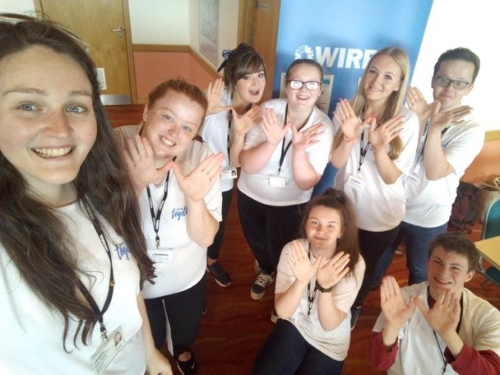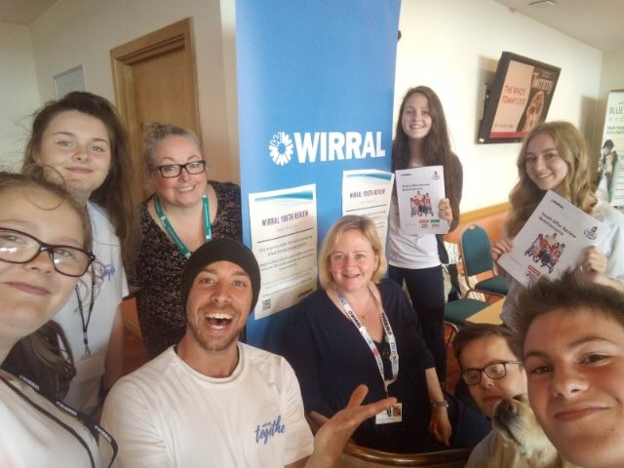

- SEND Youth Voice Conference 2019 - The event was a reflection on the 2018 SEND conference and the issues it raised. The four key themes that the young people wanted to reflect on with professionals were: -
  - Independence
  - Relationships
  - Safeguarding
  - Exploitation.

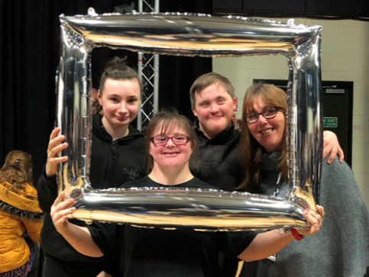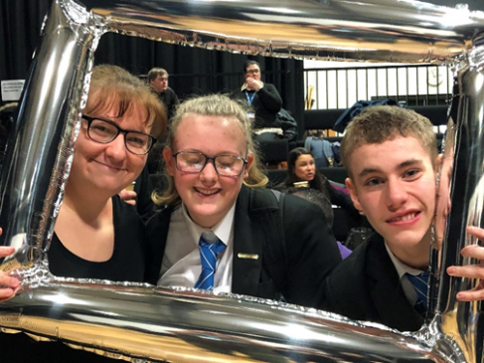

The professionals and young people explored the themes through activities and debate. The feedback
Would be taken on board by the services and organizations that attended. Raising unseen issues and
Needs which SEND Young people face in these themes.

- POSH – Pioneers of Sustainable Hope. The SEND YVG worked with the YVG to develop a film on sustainability for young people in Wirral. They presented this film to the Wirral Cool Climate board and were offered a seat on the board. The group attends and is now developing Wirral youth feedback upon the environment issues that young people feel are affecting them out in the borough wards.

- DIGITAL GROUP – A SEND YVG young person has been helping with the development of the youth digital strategy meeting once a week with Youth Matters staff. Advising and gathering feedback regarding digital developments and methods.

- Performance as part of Wirral Region of Culture for the LCR. The group performed alongside the YVG under the famous ‘moon’ installation in Wirral. As part of a special Children in Care evening.

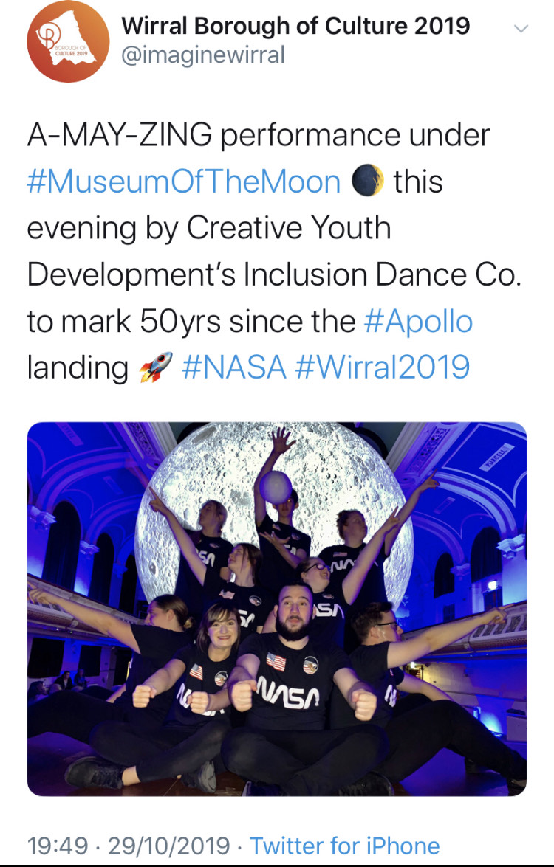

- Presentation of the Liverpool Metro Mayoral meeting in NOVEMBER 2019 for the young people of Merseyside. One of the SEND YVG was a host for the event and presented a workshop on building confidence and self esteem to over 100 young people in attendance.

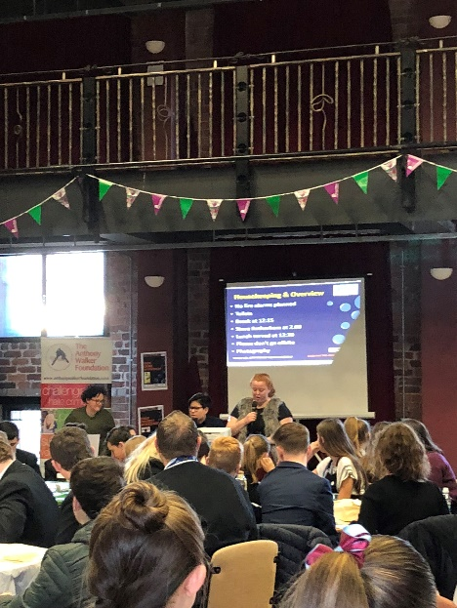

- CHESTER NEW NURSE TRAINING – As part of the training for first year nurses, a linked development of training was devised with me and Chester University NHS in regard to the development of a 3hr course for students which was planned and hosted by the SEND YVG on how to work with SEND people when on ward duty. Covering communication concerns, needs assessment and open discussion and answering questions from the students. The SEND YVG delivered at Chester University, Marris House NHS Wirral and at Warrington Campus. The SEND YVG received trainer certificates from the university for their work. Students gave outstanding feedback about the training.

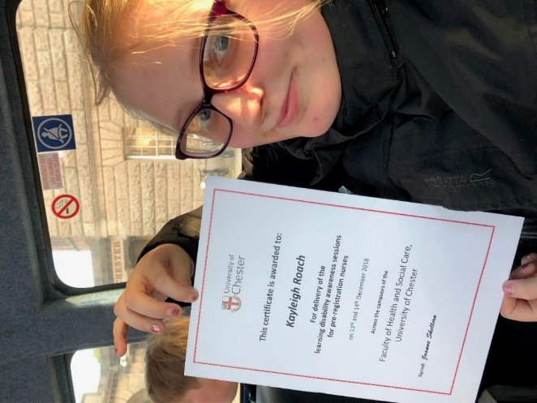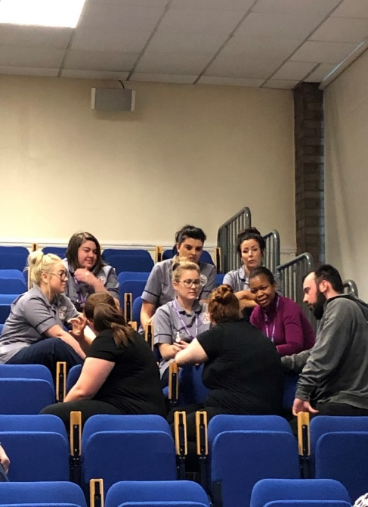

Work done by SEND YVG in 2020 (Covid 19)

- SEND YOUTH VOICE CONFERENCE 2020
The event was planned around the outcomes that SEND young people had reflected upon during their work in 2019. The theme was to look at how services and organizations work with SEND young people and how do they address their needs. The themes for discussion were based around –
- Assumptions
- Power
- Challenges
- Developments

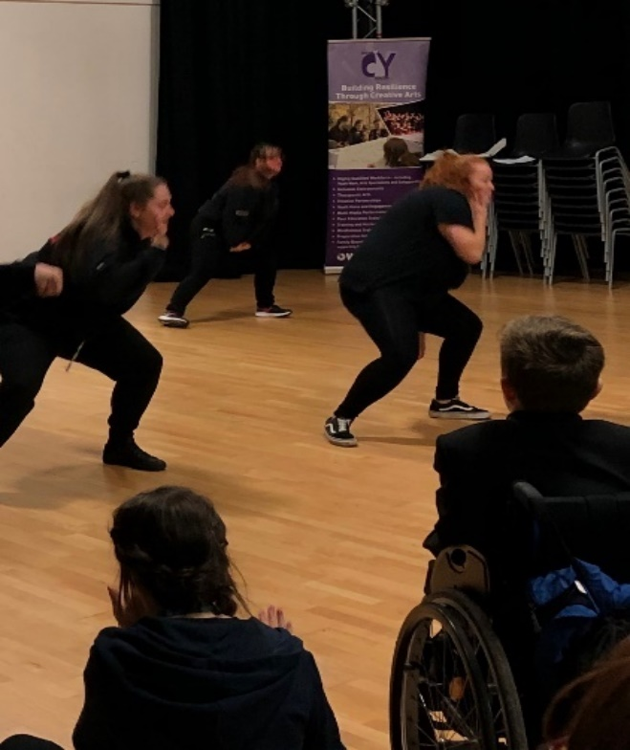

The event was a success with many positive conversations with the young people and professionals.
The performance of the ‘THE WEB’ by the young people was received by the professionals positively. A piece of rope was used and moved across the stage space by a young person, who is circled by other young people who were acting as adults in the young person’s life. It showed a real journey and issues, as the young person moved to other adults and returned to others, weaving a mess which in the end, they as the young person had to climb through, demonstrating their journey and blocks along the way. Many professionals commented on the simple visual impact of the performance on their reflection on the needs and journey of a disabled young person.

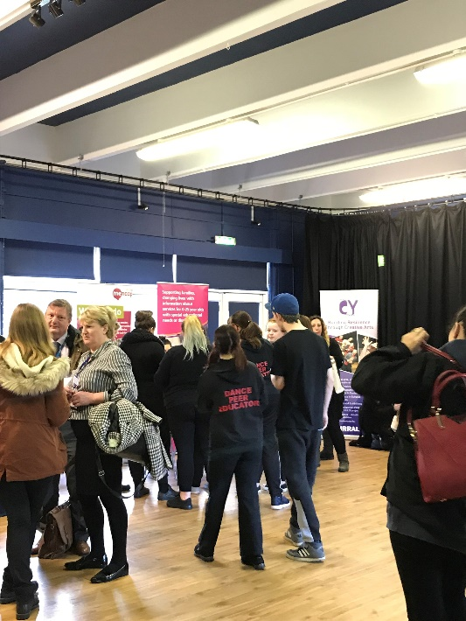

The awareness of ‘How’ we capture the voice of young people was discussed in all the groups, but young people who were the facilitators felt that the ‘method’ on how to do this was missed in conversations.
This is mirrored by the above statements, which fall under the thinking of ‘What’ must be done.
Within this conference key questions came through via the workshops -
- How do we know that the process of capturing the voice of individual or voice groups in Wirral is of quality?
- How is it being recorded faithfully?
- Where does their voice ‘go’? how are their voices being actioned and heard?
From the feedback and conversations at the conference, we hope to develop a ‘document’ in the future, which will be used with young people to capture young people’s voices and needs. This document will be co-produced and key conference attendees will be engaged with to help the SEND YVG develop this document.
This document will be part of a pack to support the capturing of young people’s voices, especially SEND. This will be done using the information from this event as the building block to the layout of the document.

From this list of what should be included in the document, I have created a draft brief on action points in the document’s development.
Who | For - Professionals to get the views of all involved in the young person’s journey  Professionals engaged that the young person has built a relationship with.
 | For - To be used with all SEND Young People and those who may not have been officially identified as SEND.
Creation & development –
SEND YVG and other target groups (children’s & Youth)
Local Offer staff
WBC SEND Leads
WBC Education Leads
What | WBC to make a pack up  Pack used across council  Pack to be circulated to all professional/organisational bodies  Pack will need a checklist  Pack should be a booklet of info  Pack should have a clear useful section with questions to encourage capturing a young person’s voice created by young people and professionals  Regular yearly celebration and case studies of success to help encourage good practice and recognise ways to adapt to young people’s aspirations.  An awards day/evening for SEND young people to celebrate achievements  Will have a communication passport with person centred plan
When | To be used –  - For meetings  - For transitions/school/college/work/carers/support services  - For all areas of health, education and social.  - For children’s services  - For cross service support/referencing  - For documentation for young person and families regarding their future aspirations.
Where | In any area where a disabled young person would be supported and access  Promoted by the Local Offer on the site and with SENCO’s and other disabled facilitators/professionals.
How | A personal work pack.  Used consistently and shared if needed and when given permission.  Filled in one area and shared with other orgs/services young person accessing so no repeat of work being done, and young person having to repeat their needs and wants.  In sections – for personal, likes, strengths, aspirations, emotions, blocks, transitions, views and welfare.  Questions will be relevant for any young person.  This process should not have any generic statements used; they should be individual to the child.  Some scenario questions will be developed to help the child express their thoughts.  Packs done in different formats – easy read, braille, film version  Will be a yearly process of review that can be used in all meetings for the child and can be updated if child feels they want to add/change anything  Staff training offered on how to talk with disabled young people and gain their confidence and feel comfortable to do the pack. (such as being able to change the adult jargon when talking to young people)  This will be a consented to and confidential piece of work with the young person.  Professionals engaged with young person should have read the document and update if it’s done with their young person.  Training with staff needed about presumptions, judgements and assumptions surrounding disabled children.  No time span pressure for the young person’s aims or aspirations to do with their adult future.  Professionals make sure that finances are discussed when young person concerned how this will affect their future as a disabled young person. Professionals to raise meetings with parents about this issue in case this is holding back the development of the young person’s choices and aspirations.  Blocks identified in pack will be challenged and worked with till a positive outcome/adaptation is developed.  Use Pack to identify the issues of support which would block a young person wether that be from parental/finance/accessibility.  Staff trained on the pack and the awareness that this should bring ease to identifying the right paths and support that the young person is wanting  Staff to be supported through introduction to use. A Pilot should be developed.  A link to attendance and NEET support for young people.  Differing ways to capture the views of the young person.  Making sure issues are addressed and not sugar coated for the young person, whilst making sure there is room for challenging for a positive outcome.

- LCRYA – The SEND YVG were part of the Liverpool Metro Mayor Youth Platform during Covid19. The SEND YVG were part of the group that helped host and deliver this online event with me and professionals across the Liverpool region. Members of Wirral and Sefton youth voice groups hosted the event with the Metro Mayor answering young people’s questions. Around 250 young people were involved in the event. The themes of discussion were Mental health, Education, Employment and Disability.

- WEEKLY ONLINE SESSIONS – The SEND YVG were online doing work during Covid19. Using a mix of dance, drama, art, discussion and debate. Plus, peer education training. Local Offer supported the sessions and where issues were raised these were escalated to the appropriate service.

- VIOLENCE REDUCTION SURVEY – A VRP-Pan Mersey commissioned piece of youth-led research into the views of young people on interventions to prevent youth violence and child criminal exploitation. This was a survey developed with Young Advisors UK. A SEND member was involved in working, developing, hosting and report writing the survey up (with staff support) alongside the Young Advisors from other area of the Liverpool City Region. Wirral surveyed over 40 vulnerable young people regarding violence reduction, and the fed into the main report developed.

- HELPLINE DEVELOPMEMT FOR COVID – The YVG and SEND YVG raised the concern that young people stuck at home during lockdown may be struggling and need to speak to someone. How could they do this when no one in an office and that they may be intimidated to call a non-child call line? This was reacted to by the COVID Response team and discussions were had on how this could be created and done. Young people from the SEND and YVG created the message and recorded it for the helpline.

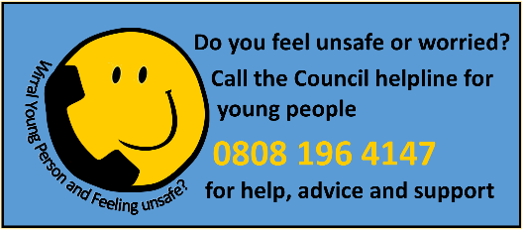

- PLANNING AND DEVELOPMENT FOR ‘YOUR FUTURE – YOUR VOICE’ – From the outcome of many pieces of work. Sally Tittle of the Local Offer had booked and developed an event to run at the Floral Pavilion for SEND young people. The SEND Youth Voice group were to present and host some of the event. This has been placed on hold during Covid 19, but has been developing with the SEND Youth Voice group via online workshops. The revised date is Wednesday 30th March 2022.

- PILGRIMBURY EVENT – An online fun weekend event for young people across Wirral. Live online workshops, craft sessions and goody bag delivery. With dance, drama, music, quizzes, debate tents, craft making, arts party and relaxation events! The SEND Youth Voice group helped host and deliver this event in workshops as peer educators, and debate leads.

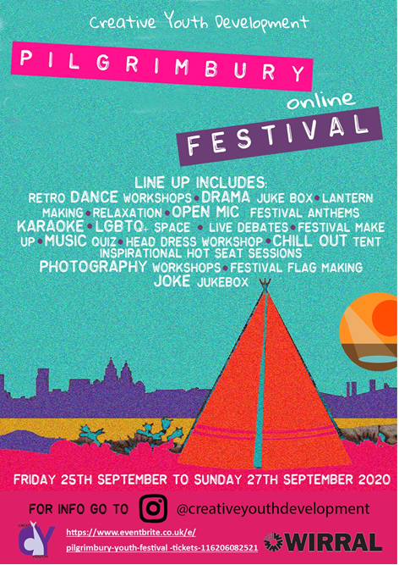

- HALLOWEEN CELEBRATIONS – The SEND Youth Voice group took part in the online event, doing a dance performance and joining the spooky celebrations.

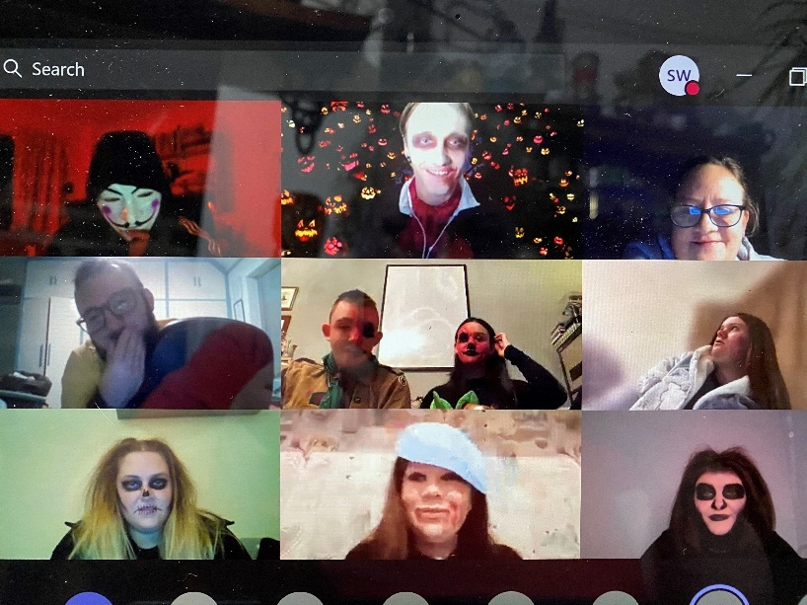

- CHRISTMAS CELEBRATIONS - The SEND Youth Voice group took part in the online event, doing a dance performance and joining the fun celebrations.

- CHRISTMAS WORSHOPS – The SEND YVG joined in across the Christmas weeks from 19/12/20 – 30/12/20. 6 different sessions from craft making, quizzes, mental health and fitness.

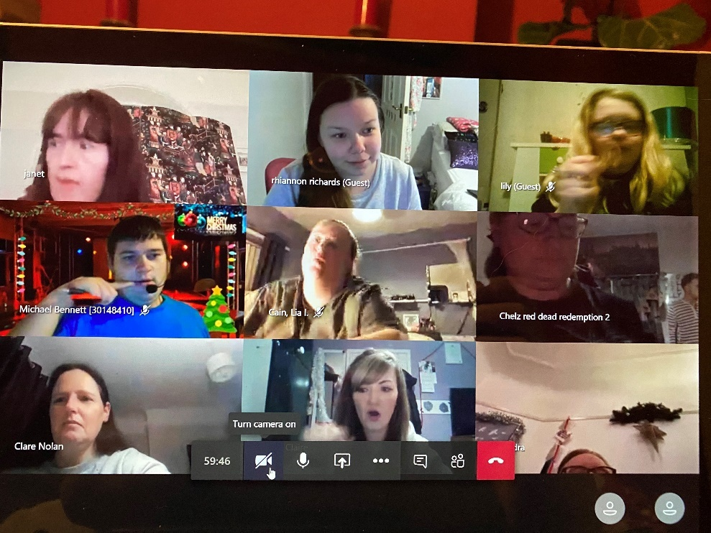

Work done by SEND YVG in 2021

- ONGOING – POSH, DIGITAL, POLICE COMMISIONER, Liverpool City Region Youth Assembly. All these projects are ongoing and developing.
- BUDGET CONSULTATION January 2021 ‘HAVE YOUR SAY’ – The SEND Youth Voice Group had a say on this. With workers supporting their input.
- YOUTH JUSTICE ‘Children First Plan’ AND SET UP July 2021 – The group had an online meeting with Youth Justice to input on the new plan.
- KEEPING STREETS SAFER SURVEY ‘FEMALES’ June 2021 - The females of the SEND YVG put in their views as young women about public spaces where they may feel unsafe.
- Kaizen Consultation Feb 2021 – OFSTED COVID FEEDBACK FAQs about the National Children’s Bureau Consultation for Children and Young people with SEND about the impact of the pandemic.
- INTERVIEWS FOR JUNO – The group were part of interviewing for the Registered Management Job for Capacity Lab. They introduced themselves and ran an activity task for themselves and candidates.
- INTERVIEW FOR NEW HEAD OF SEND – A young person sat on the interview panel for this role.
- INTERVIEW STRATEGIC LEAD FOR TRANSFORMING CARE PROJECT – A young person sat on the interview panel for this role.
- WORKED ON THE CO-PRODUCED HEALTH PASSPORT - A young person worked with Parent Carers and Health practitioners to develop a Health Passport for SEND CYP.
- REGENERATION OF BIRKENHEAD – Representatives of the SEND YVG were part of a feedback discussion with regeneration regarding the Hamilton Square Developments and the new park. This led to future meetings being planned as regeneration were impressed with the young peoples views and opinions.
- LCRYA ENVIRONMENT VOICE PANEL – representatives of the SEND YVG were involved in discussions with Merseytravel on behalf of the Liverpool Metro Mayor on the environmental issues of the Liverpool City Region, focusing on transport firstly.
- MEETING NEW Asst Director for Education – 2 SEND young people welcomed and showed the new Assistant Director of Education around Pilgrim Street Arts Centre and introduced the SEND voice groups work to him.
- COMMISIONING OF NEW DISABILITY CARE HOME – TRANSFORMING CARE SEND YVG representatives have gathered the views of SEND young people to bring to a planning meeting in regard to the development of a SEND Supported housing process.
- Development of a SEND Police YVG in Wirral – Merseyside Police have approached the SEND YVG to become a pilot project in setting up a future SEND Police YVG for Wirral and wider Merseyside.
- SEND YVG will be working towards a motion to put forward for debate for youth parliament, in Nov 2021.
- SEND YVG are working towards their conference which will hopefully be Jan 2022. The theme will be ‘Your Future- Your Voice’.
