**Co-production: What does it actually mean?** 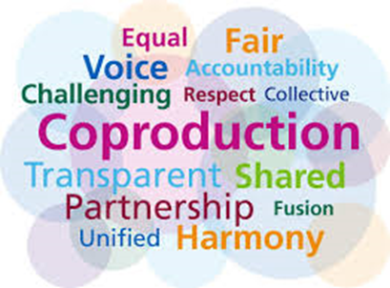

Helping people to help themselves

Teamwork

Everyone who has information has a chance to share their view

All voices at the table to design, shape and review services

The people who the project is aimed at helping to produce it

Sharing best practice to help others

Doing things, the right way around – not just consultation tick boxes

Sounds too corporate (‘work together’)

Bringing together ideas

Helping others

Eating together

Teamwork but more visual

Using recognised images

Helping each other

Working together - teamwork

Making something together

Planning together

Opportunities

Having a voice

Communication in different ways

People have different ideas and share them

Merging ideas – working in different groups as a community

Not being told what to do

Listening to service users and designing something that works for service users

We agree with community and product

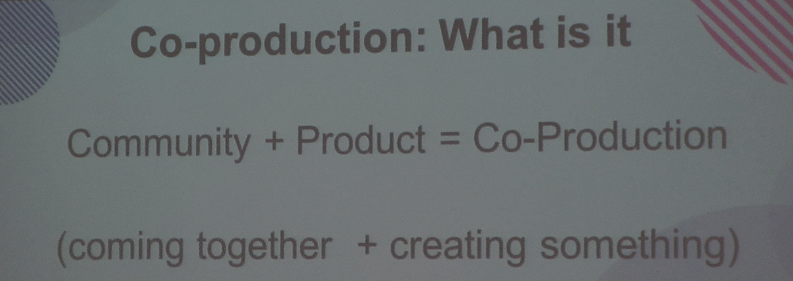

People working together

Recognition

Having fun (start to finish)

‘Making a difference’

‘Making friends’

Making things better together



**Community: what does it mean to you?**

People in my city

All ages

Groups in school

Everyone coming together

Our studio space – somewhere to get together that’s just for young people

Young people with disabilities working in youth clubs working over the age of 25

School council

Workers, friends, family, young people

Not necessarily ‘community’ but a mutual aim/reason or benefit for groups

A wide range of people

Friends

Youth workers

Decision makers

Students

Religious groups

Workers/Union

School

Teachers

Home

Siblings

Parent/Carers

Service users

Young people

Support workers

Service managers

Youth workers

Local organisations/services

Education settings

Social care

Health care professionals

**Co- production: what are you already doing?**

Drama group – social skills productions, produced with school staff and young people – Liverpool

Annual conference – young people planned, and young people led – Trafford

Local offer young people helped plan this, also travel training video

Co-production strategy – CE

Involving young people based on their needs, different roles based on needs

Insisting that all young people be part of the drama group – we changed thing as it was not inclusive

DWP – CV writing – Local Offer

Youth parliament – Wirral

Youth services

Looking at SEND separately

Greater Manchester Youth Club Access Travel Pass (GMCA)

SEND - young advisor’s w/ Council – St Helens

Lead Young Advisor for SEND

SEND conference – Longtree Park St Helens

Big chat group in St Helens

Little chat group for St Helens – little groups are for schools and colleges and youth clubs

Transition from child to adult Wirral

Health, social care and education (professionals)

DWP – CV writing – Local Offer

Youth parliament – Wirral

Youth services

Looking at SEND separately

**We are proud of** …

Being part of a new group

Being in a SEND dance group

Young people management committee members

Young people sitting on interview panels

Being part of the leaving care council partnerships – (youth inspectors)

**What has worked?**

Giving young people lots of information about what’s going on

Being part of communities – working, volunteers

‘Take over’ days

Transition from child to adult Wirral

Health, social care and education (professionals)

**What will you never do again?**

People feeding into existing groups to tick the consultation box

Consultation agencies/visiting big wigs e.g. Ofsted

**What would you like to do in the future?**

Employ more young people with disabilities

More people with disabilities in big positions

Go-to young people who are reliable be safe to consult with

More consultations on site – in the north, in schools, in youth centres. In venues in areas that are familiar ‘owned by young people’

Working with /alongside local business and shops

Having two-way contact/communication

Host/run events for young people by young people and professionals

Rochdale & Wirral: Bringing together EHC professionals to air and share = Challenges, successes and what young people want/need

Rochdale- professionals now contacting young people groups to get them involved e.g. Health commissioning re drugs and alcohol inclusive information

A SEND Youth Voice Conference - Wirral SEND youth voice hold an annual conference with professionals to understand issues affecting CYP = pledge to work closely with CYP to plan services

An event like Wirral held. A Dragon’s Den Employment event. Young people were offered paid employment, business support and CV writing skills.

Employing apprentices/supporting new businesses

Leaving professionals’ pledge unchallenged – in future we will make them accountable!

Getting better support for parent/carers so young people can gain independence

A forum of young people who are active decision makers

Making sure more CYP can share local issues nationally

The Wigan Deal

Young people events

Bank of England young people advisers

Mental health and me

Local Offer design and input with other regions

You said we did

Get young peoples’ voices heard across and taken seriously

**Co- production: Making it Happen**

**Tired of talk, time for action. How do we ensure this happens?**



* **Be persistent**
* Decide who leads, then take the first step
* Inclusion
* Consultation
* Coproduction
* Professionals attend youth groups and not the other way
* Opportunities to attend outside of school hours
* Improved communications between agencies
* Opportunities to feed in online, by phone etc.
* Clearer systems for making contact
* Consistency of meetings
* Different mechanisms for feedback
* Make sure you do what you say you will
* Professionals feedback what’s happening to YP – you said, we did
* Being more joined up with groups so networks feed into each other and are not recreating the wheel. Need a single point of contact?
* Mix people together
* Easy read versions
* More events like this
* Updates/social media newsletters
* Make sure actions have impact

**What would you like to see done differently?**

* No more posh, technical language
* YP feeling confident and able to challenge
* Act on what is heard
* Reflecting with each other
* Mix people together so there are always young people with professionals.

**Challenging the culture**

* More of a say
* Understanding needs
* Opportunities for everyone
* Always a challenge
* More funding
* Suggestion box
* Spreading out exams for SEND pupils
* Every teacher in mainstream schools should be Autism, ADHD, Downs Syndrome qualified/aware – teaching others too

**Resources & Activities:**

* Have the right people in the room
* Stop tick box activities
* Be adaptable
* Build relationships – can be uncomfortable saying personal things with strangers
* Needs analysis
* Create space for everyone to share thoughts

**Effective & Sustainability:**

* Recognise all people as experts
* Ownership
* Do what you say you will do
* Co-production champions
* Consistent funding
* Realistic timescales
* On-going process
* Accountability