Museums & Galleries in Wirral
Wirral boasts a great range of opportunities for those wanting to learn more about its rich history and culture, with a number of museums and galleries each set in its own distinct surroundings. Check out our list of them below.

https://www.visitwirral.com/things-to-do/attractions/museums-and-galleries

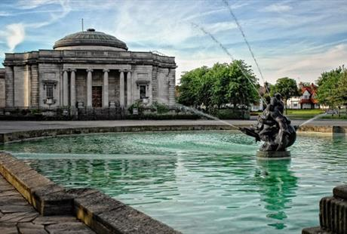

Lady Lever Art Gallery

Lever Art Gallery houses one of the UK’s finest collections of fine and decorative art and is dedicated to the memory of his William Lever's wife Elizabeth. Lever built the gallery to share his personal art collections with the public. It has the best collection of Wedgwood jasperware anywhere in the world as well as internationally renowned Pre-Raphaelite paintings. This beautiful art gallery is an inspiring half-day.

Entry: Free
Open: everyday from 10am - 5pm

except on 24, 25, 26 and 31 December and 1 January.

Port Sunlight Village
Port Sunlight
Merseyside
CH62 5EQ
Tel: 0151 478 4136
https://www.liverpoolmuseums.org.uk/lady-lever-art-gallery

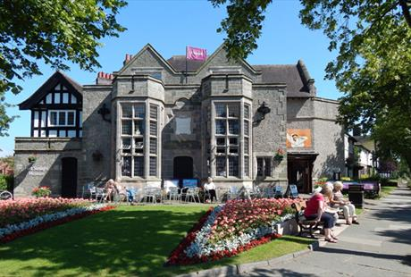

Port Sunlight Museum & Garden Village

The museum tells the story of William Lever and how the village developed, from the working conditions to the charming architecture and lively social scene. It is packed with nostalgia, from vintage soap packaging to the story of Ringo Starr’s first performance with the Beatles, which took place in Port Sunlight in 1962.

Entry: Adults £4.50 - concession, children, family and group discounts apply.

Open: Daily from 10am – 5pm

23 King George's Drive
Port Sunlight
Wirral
CH62 5DX
Tel: 0151 644 6466

http://portsunlightvillage.com/

Birkenhead Priory & St. Mary's Tower

The oldest building on Merseyside, Birkenhead Priory encapsulates so much of the town's history within a small, enclosed site. Now in the shadows of Cammell Laird's shipyards, the Priory is an oasis of calm in a busy world. Make sure you climb St Mary's Tower for unrivalled views of the River Mersey and the surrounding area.

Entry: Free
Open: Wednesdays - Sundays with summer and winter hours.

Priory Street
Birkenhead
Wirral
Merseyside
CH41 5JH
Tel: 0151 666 3537

https://thebirkenheadpriory.org/

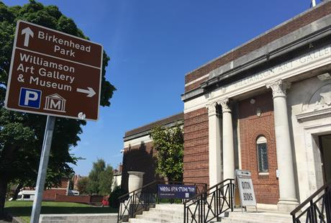

Williamson Art Gallery & Museum

One of Wirral’s hidden gems, the Williamson Art Gallery & Museum is minutes from the heart of Birkenhead, on the edge of the picturesque village of Oxton. Opened in 1928, this free art gallery showcases a vast array of works with unique exhibitions. There is also a courtyard garden which provides a quiet haven at the heart of the gallery.

Entry: Free
Open: Wednesdays – Sundays from 10am – 5pm

Williamson Art Gallery & Museum
Slatey Road
Birkenhead
Merseyside
CH43 4UE
Tel: 0151 666 3537
https://williamsonartgallery.org/

Wirral Tramway & Wirral Transport Museum

Wirral Tramway and Transport Museum is an award winning attraction which is home to trams from Hong Kong, Portugal and England. Birkenhead has a rich history with trams and launched the first street tramway in Britain which ran from Woodside to Birkenhead Park. Perfect for families, you can explore a fascinating collection of buses, cars, motorcycles and bikes and take a trip on one of their historical trams.

Entry: Free
Open: Weekends and Bank Holiday Mondays from 1pm – 4.30pm plus Wirral school holidays on Wednesdays to Sundays from 1pm – 4.30pm

1 Taylor Street
Birkenhead
Merseyside
CH41 1BG
Tel: 0151 647 2128

http://www.mtps.co.uk/

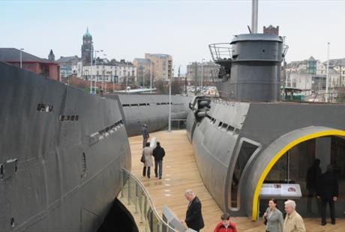

U-boat Story

Located at Woodside Ferry Terminal, this experience allows you to look into a real German U-Boat. With original film archive and interactive displays, you can witness all the dramatic action!

Entry: Adults £7.50 - concession, children, family and group discounts apply.
Open: Weekdays from 10.30am - 4.30pm and weekends from 11.30am - 3.30pm

Woodside Ferry Terminal
Mersey Ferries
Woodside
Birkenhead
Merseyside
CH41 6DU
Tel: 0151 330 1444

https://www.u-boatstory.co.uk/Pages/default.aspx

Founded in 1892 in memory of Charles Dawson Brown, who was a Churchwarden at St Bridget's Church in West Kirby, this museum shines a light on a number of carved stones and other masonry from around the time of the Norman Conquest. Step back in time and marvel at the numerous column and wall fragments from this era.

Entry: Free
Open: Saturdays from 10am-1pm

St Bridget's Centre,

St Bridget's Lane,

West Kirby,

CH48 3JT

http://www.westkirbymuseum.co.uk/

Tate Aisle Gallery is a community art gallery based in Birkenhead Market. All work displayed has been produced by local artists using a variety of themes and mediums. As a community focused gallery, it also houses artwork by charities and includes items available for purchase.

Entry: Free
Open: Mondays - Saturdays from 10:30am - 5pm

Unit A1,
Birkenhead Market,
Claughton Road,
Birkenhead,
CH41 2YH
07383830609
https://www.tateaisle.co.uk/

