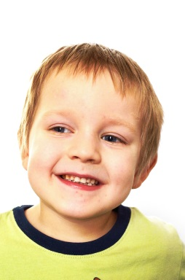
- My lovely smile.
What people like and admire about me…
- I give lots of kisses to Mummy and Daddy.
- When I dance with my little sister Rosie.
- I’m always happy.
- When I giggle lots when being tickled.
One Page Profile
- For adults to copy the sounds I make and label what I play with so I understand what the words for these things are.
- For adults to only use 1-2 word sentences and visual support so I can understand what they mean.
- To help me to use a spoon to feed myself.
- Give me lots of opportunities to play in the outdoors.
- Give me lots of time to know what’s happening next and show me visually so that I can prepare myself.
- To play lots of games to get my attention, such as blowing bubbles, peekaboo, and tickling games.
- To have a quiet area to go to when it gets too noisy.
- To make sure I follow my bedtime routine and get to bed by 7pm.
- To avoid gluten and dairy in my diet.
How best to support me…
- To be outdoors playing.
- To go on my trampoline.
- Water play and bathtime are fun.
- I like food.
- To be pushed in the pram when going out.
- To be in a quiet room.
- That adults understand what I want.
- I need lots of sleep.
SAM
What’s important to me…

