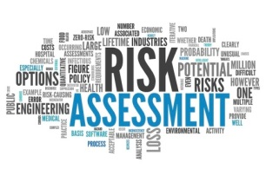
Risk Assessments – When and how they should be carried out.

Risk assessments should be carried out initially for all areas of a childcare provision children will access, and then as a continuous process. They should be reviewed as required but definitely annually. Obviously if there is a particular incident or activity taking place within the setting, for example, building work, then a risk assessment will be required. Risk assessments should include the indoor and outdoor environment, highlighting the high and low factor risks of the environment making it safe for staff, children and parents. (see template). Ideally they should be displayed within the rooms; alternatively they can be kept in a folder. Always ensure everyone is aware of where these are kept. Staff new to the setting or agency staff should also always have the opportunity to view them.
When parents trust a provider with their child they must believe and trust that their children are being well cared for, that their learning and development needs are being met and they are kept safe at all times.

When carrying out your risk assessments you should consider the following
- Decide who might be harmed and how
- Evaluate the risks and decide on precautions
- Record your significant findings
- Review your assessment and update if necessary
When thinking about your risk assessment, remember:
- A hazard is anything that may cause harm, such as chemicals, electricity, working from ladders, an open drawer etc
- The risk is the chance, high or low, that somebody could be harmed by these and other hazards, together with an indication of how serious the harm could be
The Early Years Foundation Stage (2017) page 31 – 3.64 states that:
“Providers must ensure that they all reasonable steps to ensure staff and children in their care are not exposed to risk and must be able to demonstrate how they are managing risks. Providers must determine where it is helpful to make some written risk assessments in relation to specific issues, to inform staff practice, and to demonstrate how they are managing risks if asked by parents and/or carers or inspectors. Risk assessments should identify aspects of the environment that need to be checked on a regular basis, when and by whom those aspects will be checked, and how the risk will be removed or minimised”.
Providers must also asses the risks or hazards when taking children out on trips, this must include consideration of the adult child ratios. It is for the provider to judge if there needs to be a written risk assessment or not.

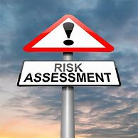
Risk assessing activities

As practitioners we need to remember that taking ‘risks’ is part of children’s learning and development, if they don’t get the chance or opportunity to risk take, they are not going to learn and be able to progress and reach their potential.

As practitioners with this in mind, risk assessments do need to be taken before activities are set out for children. If the activity is ‘unsafe’ changes need to be made, or if the activities are unsafe for some of the children, for example younger children or children who are not at the age of understanding, then the activity needs to be changed or adapted for that specific child.

This way children are not missing out on learning opportunities, but the activity has just been adapted or the risk reduced.

Risk taking needs to be learned and practiced over time, by trusting children to make their own judgement in risks; we are allowing them the opportunity to develop confidence in their own abilities.
