Outdoor Environment

Children should have access to the indoors and outdoors throughout the day, every day. This includes rainy days, when there is snow on the ground as well as sunny days. It does not include during extreme weather conditions that would put a child in danger.
Not every setting has a large outdoor area, however, some ideas are listed below on how you can enhance the outdoor area and make the best from the space you have. Even in small spaces, children can be stimulated, challenged and learn through their play, whether they are indoors or out, but we all know most children love to be outside!

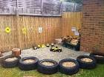
A good quality outdoor area can include:

Climbing area / encouraging gross motor skills

- Moveable equipment e.g., frames ladders, planks, tunnels and tyres. This equipment could be made from natural resources, pallets, crates, planks of wood etc. as long as it is safe for the children to play with.
- Offer stimulating physical challenges for children to challenge themselves.

Quiet and secret areas

- Provide space where children can go and be by themselves or in a small group
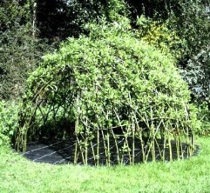
- To allow time away from the busy outdoor area, blankets, cushions, bean bags and materials can be added to an area to make it more relaxing and comfortable
- Adding books to this area can be a nice idea too.

Space to use playing equipment

- Create an area where children can ride and play with vehicles such as bikes, scooters and cars.
- This should be a large, spacious area as children need to learn and develop the skills required to be confident to operate these.
- Safety can be discussed with children when playing, and also a parking bay or garage to lock them away could be in this area.

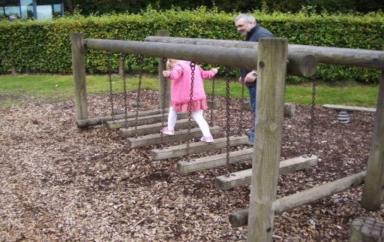

Space to develop new skills

- Space could be created to allow children to practice new skills or to play games together, such as throwing, rolling, kicking, catching or aiming balls, beanbags or hoops.
- Children can learn about turn taking and sharing and winning and losing.

Sand + water play

- Create a space within your setting where children can have access to sand and water.
- Sand can be placed in a sand pit that is outside or indoors, sand trays on wheels that can be imported indoors and out are really useful.
- The same goes for water too, you could invest in an outdoor tap so children can access to it when needed, to fill up bowls, containers and buckets.
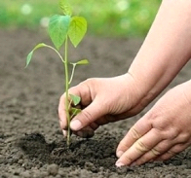
Natural areas / areas for planting and growing

- This area doesn’t need to take up much space; it can be fixed in one area, placed on a wall, or transported around different parts of the garden.
- This area may be raised beds, hanging baskets, old tyres filled with compost and flowers, bulbs and seeds.
- Encourage children to investigate the natural environment and to get involved with planting the flowers or vegetables.
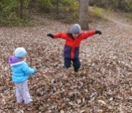
- Child friendly gardening tools should be available for children and appropriate weather clothing.

Space to be creative

- Provide materials such as milk crates, tyres, and cardboard boxes for children to be imaginative and creative.
- Mark making can be explored in so many different ways outside, and this may encourage all children to take part.
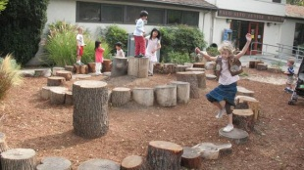
- Having resources like paint rollers, big paint brushes, large chalks, blackboards, pens, pencils, brushes and water can help develop children’s mark making skills.
- Children can help to collect natural resources such as shells, fir cones, conkers, leaves and pebbles these can be collected from the garden or if on outings anywhere and can be stored in baskets.
- Provide sound walls or sculptures from old pans, baking trays, and utensils to make instruments and explore different sounds.

