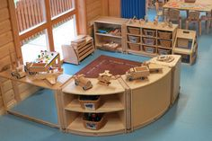
A good quality indoor area can include:

Home corner

A home corner could contain the following:
- A wide range of fabrics, which can be used for a variety of purposes. E.g. animal prints, clothes, soft blankets etc.
- Cooking utensils, food containers and packaging
- Kitchen furniture - if no furniture is available, this could be made out of cardboard boxes or any other recycled materials.
- A range of dolls in a range of skins tones, dolls clothes and equipment
- Books, paper and pens available for children to write down notes or make lists.

Role play

Role play areas can vary each week/term as children develop their interests, some ideas to have in a role play area are:
- Dressing up clothes,
- Props that can be used in a variety of ways such as every day materials - scarfs, hats, drapes, hand bags.
- Shop and office equipment, tills, phones, old computer desk tops, money.
- Keeping the role play tailored to the interests of the children, observing them playing and interacting can help you to create different themes such as:
vets, doctors, pirates, dinosaurs, castles and dragons.

Creative workshop/ mark making

An area of the room needs to be set out so children can be creative and mark make. This should be an area where they can access different materials and be creative. It can include:
- Well sorted modelling resources- plastic bottles, boxes, straws, milk bottles, egg cartons.
- Glue and Sticky tape.
- A range of paper, including different sizes, card, sugar paper, tissue paper,
- Scissors.
- Well organised pencils, crayons, chalks, pens – so children have a range of mark making tools to choose from.
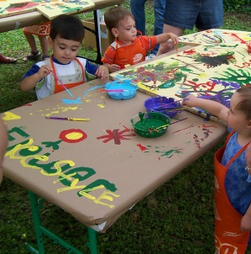
- Painting tools with a variety of different sized paint brushes, thick and thin so children can make different marks.
- Paint pots and paint available on a painting easel
- Aprons available for children to wear.

Tactile or sensory

Children need time, space and resources to be tactile and explore their senses. To help them achieve this, see the activities and resources listed below.
- Open access to resources throughout the day.
- Play dough or clay, providing cutters, rolling pins, textured materials, garlic presses, bun tins, bowels and utensils.
- Builders trays or tuff trays which you could add gravel, soil, lentils, rice, gloop (cornflour and water) shaving foam, or pasta.
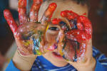
- Replenish resources when needed and add materials/resources to it to stimulate children’s learning and imagination.
- Always check for allergies.

Music and dance

Children need the time and space to express themselves through music and sound, this can provide calm and relaxation to some children. Below you can see how you can incorporate music and dance into children’s day.
- Listen to music from a range of cultures, varying sounds, tempo and rhythms.
- Provide instruments from different cultures and that have a range of sounds for children to play and explore with.
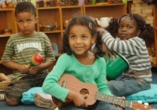
- Also encourage use of instruments that children could then go on to learn as a hobby, such as guitar, drums or piano.
- Plan visits to the theatre or dance studio.
- Arrange for visitors to come to the setting to teach the children different types of dancing.
- Watch video clips to observe performances of music and dance.
- Give children space and an area to let them move around and dance freely, enhancing this play with ribbons, streamers scarfs and bells.

Quiet space to rest / book area

Some days can be quite challenging and stressful for young children so a space where they can go and get away from it all is crucial.
When providing quiet spaces:
- Make sure this in a space where it is not busy or loud, but still within the room.
- Supply cushions, bean bags or drapes to soften noise and make the area more private.
- Quiet areas can promote good communication skills and help to develop children’s speech and language development.
- Provide some books and soft toys, and soft lighting.
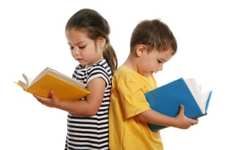
- In the book area provide a wide range and selection of books for children to choose from, fiction and non-fiction books which children can access independently.
- Include big and small books, board books, and homemade books with photographs.
- Create a comfortable space for adults to share books with children
- Provide puppets and props for storytelling.
- Create story sacks for favourite stories.

Construction play

- Good quality wooden blocks.
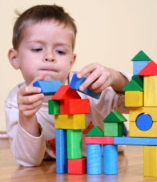
- Small world toys and vehicles, to encourage children to use their imagination when playing.
- Ensure that all the resources look clean and tidy.
- Include paper and clipboards to encourage mark making for older children.
- You can also include traffic cones, planks of wood and dressing up outfits complete with builder’s hat.

Exploration and discovery

Ideas to encourage children to explore and discover their learning environment include:
- Provide magnifying glasses, nets and buckets.
- Offer a range of resources, such as magnets, torches and pulley systems.
- Collect items with the children - such as utensils, fabrics, wooden or metal objects, and natural resources.
- Children should have access to ICT equipment, computers, I-pads and digital cameras.
- Provide mechanisms with buttons and flaps on for younger children to learn and investigate how things work.

Displays

When completing a display:
- Ensure displays are interesting and interactive for the children.
- Include the children’s own work and photographs of their recent experiences.
- Celebrate children’s individual creativity, by allowing activities to be child led.
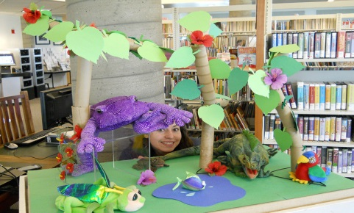
- Ensure that displays reflect the diversity of the setting, and the wider community.

