Working in partnership with parents

Good practice starts as soon as a parent/carer contacts your provision. Then at that first visit make sure you are fully prepared and welcoming – first impressions do count!

Parents/carers are the most important people in a child’s life; they are the child’s first and primary educator. Children first learn about the world, and their place in it through conversations, play activities and routines provided by parents/carers. It is important to always include parents/carers in the child’s learning and development, to allow this to be supported and continued within the child’s home.
There are various practical ways this can be done including;
- Let parents/carers know what particular activities/experiences will take place within the setting – for example by displaying routines and sharing planning sheets
- Send photographs home with a description of activities and the learning involved.
- Find out what children are interested in at home and develop this within the setting – also share with parents/carers if a child has a particular interest within the setting.
- Invite parents/carers to share any information, relating to culture and traditions that may support the child’s learning and development within the setting.
- Organise information sessions for parents/carers – share the importance of working together; provide information relating to the EYFS and how the framework supports children’s learning.(EYFS parents leaflet in section 3)
- Share leaflets, tip sheets and resources with parents
- Allow parents/carers to borrow books, CD’s etc.
- Make learning kits available – these could be linked to particular themes.
- Develop a newsletter containing useful information such as important dates, words of songs/rhymes, policy updates and ideas for activities to do at home.

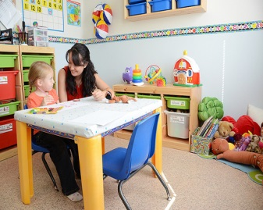
By working together parents/carers and practitioners can enhance children’s learning and development, therefore enabling them to reach their full potential. Always make time for parents to share any concerns they may have, in relation to either their child’s progress or home circumstances.
It is good practice to have a policy in place regarding working in partnership with parents. This clearly states the expectations from both parties and can include;
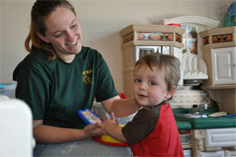
- Information relating to contracts and records
- Ways of communicating and sharing information
- Information relating to Ofsted inspections
- Information relating to policies and procedures
- Any other information you feel is relevant to your setting

Key Person

A child’s key person is responsible for supporting the child to feel safe and secure within the setting. This is crucial in enabling the effective development of parent partnership working – if you are a childminder then you are the keyperson!
These responsibilities include;
- Promoting a positive relationship between nursery/childminder and home – create a bond with the parent/carer
- Support the child to settle into the setting, this will also involve reassuring the parent/carer.
- Provide daily feedback in relation to care needs and any learning that takes place.
- Sharing important information such as accident or medicine permission forms.
- Have good knowledge of the child’s interests and developmental stage, to facilitate in planning appropriate and interesting activities, resources and experiences.
- Complete all necessary observation, assessments and tracking in relation to key children.

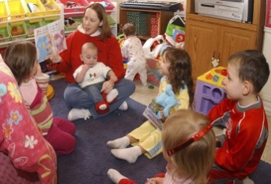
Supporting Partnership Working with Other Settings

There are a variety of reasons a parent may choose to send a child to multiple settings. A child’s ability to cope with attending more than one setting will vary greatly. These transitions mean that children may experience a change to their physical environment, routine, curriculum and caregiver, it is no wonder that a child may feel their whole world is changing at these times.

It is crucial to have robust systems in place to ensure continuity of care and effective information sharing.
It is vital that all settings involved, develop a shared approach to care and learning and have no conflicting expectations of children.

Settings will have a variety of ways to facilitate this, including:
- A shared daily diary
- A letter of introduction (see example)
- Sharing information verbally
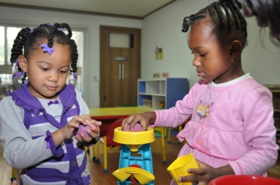
- Use books, photographs, images to support the child in becoming familiar with each environment.
- Have a buddy system.
- Develop an induction process.
- Develop a “Welcome to our setting” pack
- With parents’ permission, plan formal meetings between providers – especially if a child has Special Educational Needs or Disability (SEND).
- Share planning sheets and summative assessments (with parents’ permission)

This list is not exhaustive and I am sure you can think of many other ways to facilitate this partnership, in order to provide continuity and the most appropriate care and learning for the children within your setting .

Partnership working with other professionals

In order to meet the needs of children and families, you will often need to seek support from outside agencies. This can mean working with a range of professionals and can sometimes present challenges. The following strategies will help make the process easier:

1. Find out what services are available locally
In order to signpost families, practitioners need to know what services are available in their area. The Local Offer website is a good place to start, as it provides a range of up-to-date, local information, including voluntary and statutory services that support families.
2. Contact your local children’s centre
It is always worth contacting your local centre to find out what is available. Typically, they offer parent groups, health visitor input, stay-and-play sessions and financial advice. You can find your closest centre here. https://www.wirral.gov.uk/early-years-and-childcare/childrens-centres
Consider publicising events on your notice board or mentioning them to all parents as part of your induction process.
3. Make links with your health visiting team
Health visiting teams provide support and advice to parents and carry out a number of universal child health reviews. Unless there are safeguarding concerns, you will need written parental permission to contact a child’s health visitor. It is best to ask for this as part of your induction process but it would be good practice to tell parents when you are making contact and why, especially if the child may be having an integrated 2 year review. All settings on Wirral have an allocated link health professional (LHP), you can find out who is allocated to your setting by contacting your local clinic, the contact details are;
West Wirral – Greasby clinic – 0151 514 0219 (Select West) – wcnt.hvwestwirral@nhs.net
Birkenhead – St Catherine’s Health Centre – 0151 514 0219 (select Birkenhead) – wcnt.hvbirkenhead@nhs.net
South Wirral – 0151 514 0219 (select South) – Bridle Road Clinic – wcnt.hvsouthwirral@nhs.net
Wallasey – Albert Lodge, Victoria Central Hospital – 0151 514 0219 (select Wallasey) – wcnt.hvwallasey@nhs.net

Health, education and social care professionals keep extensive records, complete a range of statutory procedures and attend many meetings. They have a heavy workload which means that it is sometimes difficult for them to contact all the settings attended by the children they work with.
However, they will usually be very pleased if you contact them (with written parental permission) and will often give you advice and strategies that will benefit the child you are working with. If you would like them to attend a meeting, they will need as much notice as possible, usually at least a month unless the circumstances are urgent.

5. Don’t be afraid to ask!
If you are unsure of the roles of some professionals (particularly if you are working with a child with Special Educational Needs) the Early Support resource “Information on people you might meet” is useful and can be found at https://councilfordisabledchildren.org.uk/sites/default/files/field/attachemnt/earlysupportinformationpeopleyoumaymeetfinal.pdf
If you are unsure of a professional’s role then it is best to ask, particularly when you are attending a meeting with more than one professional in attendance. All professionals (including early years practitioners!) use jargon and abbreviations at times, so try to avoid this during discussions as it can create unnecessary barriers, particularly for parents.
Although it can be intimidating to contact and meet with other professionals, as an early years practitioner you are also a professional and your opinion is valuable. It is important to remember that parents have chosen your setting to meet the needs of their child and feel confident in your ability and extensive knowledge.

