What does a quality Early Years environment look like?
A quality Early Years environment is comfortable, interesting, attractive and age appropriate for the child or children who use it. Space needs careful planning, as it needs to be flexible to accommodate children’s changing interests and needs.
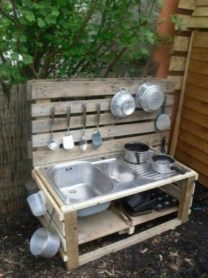
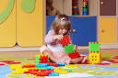
Children’s learning and development is directly impacted on by the quality of the environment around them. For some children, it becomes like a second home where they eat and sometimes sleep. A suitable environment for a young baby will be very different from a suitable environment for a four or five year old although some features will be the same.
Environments should be attractive and make children feel safe and secure and happy to be there and they should also be places where children can confidently play and learn. An Early Years setting should inspire children’s creativity and feed their imagination while leading them through the stages of development.
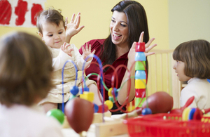
It is important that the environment can be accessed by all children, and be flexible enough to always meet their ever changing needs and interests.

This section explores further into what a quality Early Years environment could include.
Continuous Provision
Continuous provision refers to the resources and provisions that are always available to the children in your care. It consists of the resources and areas that children can access and develop their learning without adult support, enabling them to be active learners.
The environment should challenge young children, whilst encouraging them to explore independently within a safe space.Continuous provision supports children’s learning and development across all seven areas and also the characteristics of effective learning identified within the EYFS.
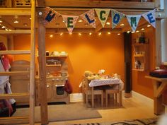
Continuous provision also enables children to return to their explorations and consolidate their learning, over the course of a day or a more extended period.
The role of the practitioner is crucial to ensuring that a high quality environment is provided, as well as ensuring that children are supported to interact with the resources. When children are interacting with the continuous provision, it is a good opportunity to carry out observations which will determine how you will enhance the provision at a later stage. Through observations practitioners will be able to identify key elements of children behaviour, interests and patterns of children’s learning and development
It is important to create a culture where children understand their boundaries and what is expected of them. When children understand what is expected of them, this gives them a confidence to explore and try new challenges, rather than return to ‘familiar’ play which may be less stimulating.
When thinking about implementing a continuous provision approach it is important to consider all three elements
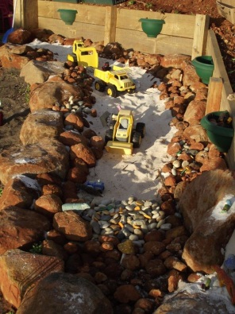
- Indoor Environment
- Outdoor Environment
- Emotional Environment

Enhanced Provision
Enhanced provision is adding resources to your continuous provision which enhance the children’s learning and offer further challenges.
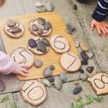
Creating enhanced provision doesn’t have to be expensive. You don’t always have to provide new resources. You can use familiar resources in different ways. This way, children will be confident in handling the resources and knowing their possibilities but be confident to use them in more challenging contexts.

Resources and Materials
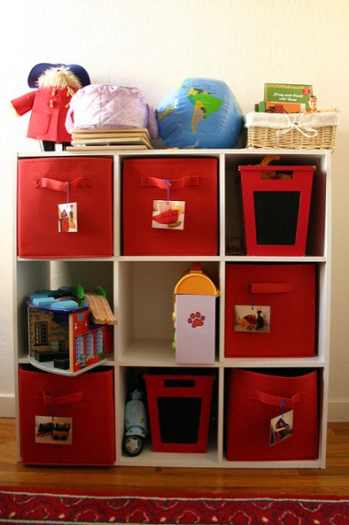
Resources should be good quality, well maintained and reviewed on a regular basis. Boxes and trays should be labelled with pictures and words, and be accessible to all children.
It is also important that resources are well organised, and do not clutter the space where children play.
All areas should be organised in a way that will enable children to make individual choices and select and return equipment independently.

Open ended/loose parts
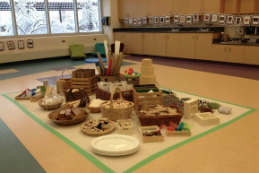
It is important to consider the type of resources that are on offer in your setting. Think about how much of what you offer is based on children producing an end product or completing a specific task? Loose parts play offers free reign to your children’s imaginations and creativity.
In early childhood education settings, loose parts mean alluring, beautiful, found objects and materials that children can move, manipulate, control, and change while they play. Children can carry, combine, redesign, line up, take apart, and put loose parts back together in almost endless ways.
These materials come with no specific set of directions, and they can be used alone or combined with other materials.
Children can change them into whatever they wish. For example - A stone can become a character in a story, or an acorn can become an ingredient in an imaginary soup.
Loose parts possess infinite play possibilities without one single outcome or specific set of directions. Loose parts can be joined, grouped or separated in endless ways. Scarves can be blankets, clothing, covers or even a picnic table.
Loose parts play can be done for free, and encourage your setting and families to be creative in play as well as recycle and re-use old materials.
Sources of further information

- See “Are You Ready for Me?” to audit your settings Emotional Environment

- See section 1 of this provider file for a full Environmental audit

- Physical activity in the Early Years http://www.ssehsactive.org.uk/earlyyearsguidelines/index.html

- Early Years Resources
https://www.twinkl.co.uk/

- EYFS Development Matters
https://www.foundationyears.org.uk/files/2012/03/Development-Matters-FINAL-PRINT-AMENDED.pdf

- “A modern day approach to Early Childhood”
http://www.thecuriosityapproach.com/

