Training
Staff training is vital in the Early Years sector, in developing knowledge and skills to provide a safe, caring, high quality provision for all children.
There are many different training courses available to Early Years professionals covering all areas of practice; these can range from language development to schematic play. Mandatory training includes; Paediatric first aid and Safeguarding. Before registering, potential childminders are required to have completed training that supports them in understanding and implementing the Early Years Foundation Stage Framework
Mandatory training

Paediatric First Aid

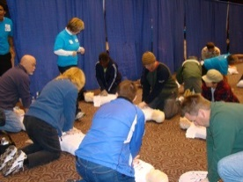
From September 2016, newly qualified staff with a childcare level 2 and 3 qualification must have a full paediatric first aid certificate to be included in staffing ratios. Paediatric first aid is a valuable training course to have, promoting the best outcomes for the health and safety of children. It is essential that each setting has at least one qualified first aid practitioner on site to administer emergency first aid. This training can be offered in a variety of ways, however most practitioners will require a full 12 hour training course.

Safeguarding
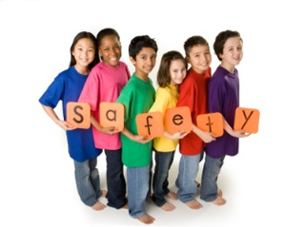
Safeguarding is a crucial element of Early Years. It is important that all parents, practitioners and professionals are safeguarding children’s welfare at all times. Child protection or safeguarding training level 1 can support practitioners in recognising signs and symptoms of potential abuse and reporting concerns correctly. It is imperative that all practitioners are aware of safeguarding policies and procedures within the setting. If you are the setting’s Designated Safeguarding Lead or a childminder it is recommended that you complete a level 2 safeguarding course

Recommended Training
Behaviour Management
Some children can find it difficult to express their emotions and will need support managing their behaviour. Many practitioners will have some experience or knowledge of behaviour strategies; however completing regular behaviour management training will support new ideas and ways of dealing with challenging behaviour. Staff training will also aid practitioners in supporting parents with behaviour at home. Setting SENCO’s may be able to support practitioners in accessing this information through in house training opportunities such as staff meetings or training evenings.

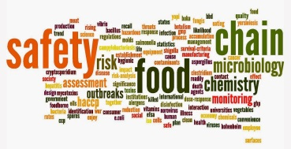
Food Hygiene
It is recommended that any practitioner that prepares food in the setting should hold a certificate in Food Safety; this is to meet basic health and safety requirements. Those in charge of preparing food must have an understanding of food storage, cross contamination and good hygiene practices. In most settings one or two people are responsible for preparing the food; however other practitioners may then serve or have contact with the food. It is a good idea for all staff to complete this training to ensure every individual has the basic understanding of food hygiene. Food Safety courses can be accessed online enabling practitioners to complete the training easily and during their working hours.

Health and Safety

Health and Safety is another crucial aspect in Early Years settings. The job role can include a great deal of physical handling and lifting, it is important for all individuals to have an understanding of health and safety procedures, relating to issues such as manual handling. Staff members can gain information through policies and procedures within the setting, however facilitating staff training will enable practitioners, to fully understand their own role in all health and safety aspects of the setting. Information from training should support practitioners in risk assessing the environment, and promote the safety of children, parents, staff and visitors to the setting.

The above are just a few examples of some recommended training – there are many more courses available to support Continuing Professional Development (CPD).
It is important that all practitioners are able to access staff training opportunities to build on their professional development and support them in their role within the setting. Regular staff supervision and peer observations provide an opportunity for managers to identify any gaps in practitioner’s knowledge and skills and identify appropriate training.
Managers must ensure that all staff receive a thorough induction program to support them in understanding their role and responsibilities. An induction program should include information regarding roles & responsibilities, emergency evacuation procedures, safeguarding, child protection and health & safety etc.

Training websites:
https://www.wirral.gov.uk/early-years-and-childcare/training-childcare-providers
http://eyqtraining.co.uk/
http://www.ndna.org.uk/childcare-training-online
https://www.pacey.org.uk/training-and-qualifications/
https://www.pre-school.org.uk/early-years-training-and-qualifications
https://www.mortonmichel.com/ChildCareClub/Training/
http://www.outofschoolalliance.co.uk/essential-training

What is Continuing Professional Development?

CPD refers to the process of tracking and documenting the skills, knowledge and experience that you gain both formally and informally as you work, beyond any initial training. It's a record of what you experience, learn and then apply.
Continuing professional development is important because it ensures you continue to be competent in your profession. It is the means by which you maintain your knowledge and skills related to your professional life. It is an ongoing process and continues throughout a professional’s career.

As an individual, regularly updating your continuous professional development is highly important when working in the early years. This ensures that yourself and your team continuously refresh and update skills, in order to demonstrate outstanding practice.
Children learn through play, from adults, role models and their peers. The daily experience of children in early years settings and the overall provision depends on all practitioners having appropriate and relevant qualifications, skills and training to provide knowledge and understanding, of their roles and responsibilities towards children’s learning and development. Providers must ensure that all staff receive induction training to ensure they safeguard children and themselves. Providers must support staff in their professional development, to ensure they offer quality learning and development experiences that enhance children’s learning and their own. Staff supervisions should be set regularly, this is a chance for any training requirements to be identified and discussed between practitioner and management. (see supervision template)
Training courses available
Underneath you can find some links to training courses available across the Wirral

https://www.wirral.gov.uk/early-years-and-childcare/training-childcare-providers
and
http://www.eyqtraining.co.uk/

If you belong to a professional organisation such as Professional Association for Childcare and Early Years (PACEY), The Pre-school Learning Alliance (PLA) or the National Day Nurseries Association (NDNA) – you will find a wide variety of courses available to members

