**Special Educational Needs and Disabilities (SEND) in the Early Years**

**Statutory Requirements**

The leaders of early years settings should establish and maintain a culture of high expectations that expects those working with children with SEN or disabilities to include them in all the opportunities available to other children so that they can achieve well.

The EYFS is based on a set of guiding principles and seeks to provide: equality of opportunity and anti-discriminatory practices, ensuring that every child is included and supported(DfE 2017 *Statutory Framework for Early Years Foundation Stage)*

**EYFS:**

* sets out an inclusive approach designed to be responsive to individual needs
* requires settings to have arrangements in place to identify and support children with SEN or disabilities
* requires all providers to make information available to parents about how the setting supports disabled children and children with SEN
* requires practitioners to review children’s progress and share a summary with parents
* requires all settings to promote the good health of children attending the setting and to have and implement a policy, and procedures, for administering medicines
* expects all settings to appoint a Special Educational Needs Co-ordinator (SENCO)
* focuses on delivering improved outcomes and closing the achievement gap between disadvantaged children and others. This includes involving parents in identifying needs, deciding outcomes, planning provision and seeking expertise at whatever point it is needed.

For more detailed information: [www.foundationyears.org.uk/**eyfs**-statutory-framework](http://www.foundationyears.org.uk/eyfs-statutory-framework) and <https://www.gov.uk/government/publications/early-years-foundation-stage-framework--2>

Early years settings must promote equality of opportunity and must not discriminate

against, harass or victimise children with disabilities. Settings must not discriminate:

directly or indirectly for a reason arising in consequence of a disability or by failing to make a reasonable adjustment. Settings must make reasonable adjustments to ensure that disabled children are not at a substantial disadvantage compared with their peers. This includes adjustments to any provision, criterion or practice, making physical alterations and providing auxiliary aids and services. This duty is anticipatory: settings must look ahead and anticipate what disabled children might need and what adjustments might need to be made to prevent any disadvantage.

Essential reading and more detailed information can be found at:

<http://www.councilfordisabledchildren.org.uk/resources/disabled-children-and-the-equality-act-2010-for-early-years>

and

<https://shop.pre-school.org.uk/A134/guide-to-the-equality-act-and-good-practice>

All early years providers must have regard to the **Special Educational Needs and Disability Code of Practice: 0-25 years (2015).**

**The Code requires:**

* early identification and an early response to SEND
* identification of SEND with parents
* a graduated approach to responding to SEND
* a cycle of assess, plan, do, review
* the involvement of specialists where a child continues to make less than expected progress

1. **Universal Inclusive Practice: high quality teaching to meet the needs of children**

High quality teaching that is differentiated and personalised will meet the individual needs of the majority of children and young people. Some children and young people need educational provision that is additional to or different from this.

*(DfE and DH (2015) SEN and disability code of practice: 0-25 years, para 1.24)*

High quality teaching is key to children’s learning and development and forms the basis for any additional or differentprovision for children with SEN. High quality teaching is based on the highest expectations for individual children, draws on what staff know about children’s learning and development, is differentiated for individual children and uses a range of pedagogic approaches.

Practitioners must consider the individual needs, interests, and the stage of development of each child in their care, and must use this information to plan a challenging and enjoyable experience for each child in all areas of learning and development.

(*DfE 2*014 *Statutory Framework for Early Years Foundation Stage,* para 1.6)

In planning and guiding children’s activities, practitioners must reflect on the different ways that children learn and reflect these in their practice. Three characteristics of effective teaching and learning are:

• **playing and exploring** - children investigate and experience things, and ‘have a go’

• **active learning** - children concentrate and keep on trying if they encounter difficulties, and enjoy achievements; and

• **creating and thinking critically** - children have and develop their own ideas, make links between ideas, and develop strategies for doing things.

(*DfE 2014 Statutory Framework for Early Years Foundation Stage, para 1.9)*

1. **First Concerns and Early Identification**

**Early Responsiveness**

Throughout the early years, if a child’s progress in any prime area gives cause for concern, practitioners must discuss this with the child’s parents and/or carers and agree how to support the child. Practitioners must consider whether a child may have a special educational need or disability which requires specialist support. They should link with, and help families to access, relevant services from other agencies as appropriate.

Providers **must** have arrangements to support children with SEN or disabilities. These arrangements should include a clear approach to identifying and responding to SEN. The benefits of early identification are widely recognised - identifying need at the earliest point, and then making effective provision, improves long term outcomes for children.

All those who work with young children should be alert to emerging difficulties and respond early. In particular, parents know their children best and it is important that all practitioners listen and understand when parents express concerns about their child’s development. They should also listen to and address any concerns raised by children themselves.

**Deciding whether a child has SEN**

The key questions that need to be decided are:

• Does the child have a learning difficulty, that is, a significantly greater difficulty in learning than their peers? A key consideration, but not the sole consideration in this, is whether the child is making expected progress; or

• Does the child have a disability that prevents or hinders them from making use of the facilities in the setting?

• Does the learning difficulty or disability call for special educational provision, that is, provision that is additional to or different from the provision normally made available?

**

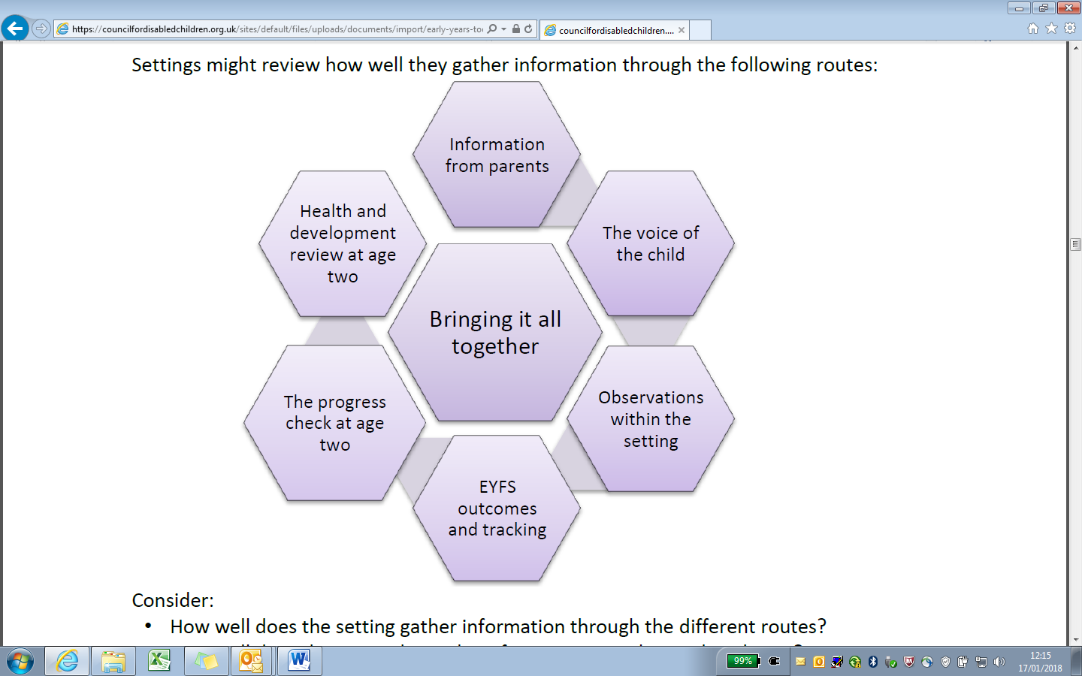

1. **The Graduated Approach**

SEN Support is designed to provide a graduated approach based on a cycle of action that can be revisited with increasing detail, increasing frequency and with the increased involvement of parents. Throughout the graduated approach, the practitioner, usually the child’s key person, remains responsible for working with the child on a daily basis and implements agreed interventions. The SENCO supports individual practitioners and leads and co-ordinates the graduated approach across the setting.

**The 4 areas of need and support:**

Special educational needs are generally thought of in 4 broad areas of need and support:

• Communication and interaction

• Cognition and learning

• Social, emotional and mental health

• Sensory and/or physical needs

*(SEN and disability code of practice, para 5.32 and para 6.28 onwards)*



**SEN Support: A Graduated Approach in the Early Years**



**Assess**

Measure the child’s progress and stage of learning and development.

**Plan**

Agree outcomes, interventions and support. Measure impact on progress, development and behaviour within a fixed time frame. *(SEN and disability code of Practice*, para 5.40)

**Do**

The Key Person implements the agreed interventions/programmes, supported by the SENCO. *(SEN and disability code of Practice,* para 5.42)

**Review**

Review effectiveness and impact of support with SENCO and parents and agree next steps. (*SEN and disability code of Practice,* para 5.43)

**SEN support: what next?**

At each cycle the key person and Special Educational Needs Co-ordinator (SENCO) consider, with the parents, and informed by the child’s views, whether the child is making expected progress, and whether:

• Special educational provision and SEN support continue to be required

• To revisit the cycle in more detail or with increased frequency

• More specialist assessment may be called for

• Staff require more specialist advice or the child requires more specialist support

• More specialist expertise is needed to inform reasonable adjustments and access arrangements for a disabled child

• The child requires an Educational Health Care Plan (EHCP) and needs assessment

**Keeping records and sharing information**

Practitioners **must** maintain a record of children under their care as required under the EYFS framework. Such records about their children **must** be available to parents and they **must** include how the setting supports children with SEN and disabilities.

*(DfE and DH (2015) SEN and disability code of practice: 0-25 years, para 5.50)*

* **Paperwork –** *see templates*
  + Play Plan (for children requiring a more targeted approach )
  + Early Years Additional Support Plan (for children who have a higher level of need, and involvement from other professionals)
  + Individual Health Care Plans (for children with physical/medical needs)

1. **Role of the Early Years SENCO**

Providers must have arrangements in place to support children with SEN or disabilities.

Maintained nursery schools and other providers who are funded by the local authority to deliver early education places must have regard to the Special Educational Needs (SEN) Code of Practice. Maintained nursery schools must identify a member of staff to act as Special Educational Needs Co-ordinator and other providers (in group provision) are expected to identify a SENCO.

**The role of the SENCO involves:**

* Ensuring all practitioners in the setting understand their responsibilities to children with SEN and the setting’s approach to identifying and meeting SEN
* Advising and supporting colleagues
* Ensuring parents are closely involved throughout and that their insights inform action taken by the setting, and
* Liaising with professionals or agencies beyond the setting

**Requesting support from the Early Years SEND Officer**

A request for involvement from the **EY SEND Team** can be made by settings after following the graduated approach, and if the setting SENCO requires further support and advice for a child in their setting. The request form is also available on Wirral’s Local Offer website <http://localofferwirral.org/>

1. **Involving Parents and Carers**

The Code of Practice expects practitioners to engage parents in decision-making throughout the SEN process. Throughout the early years, if a child’s progress in any prime area gives cause for concern, practitioners must discuss this with the child’s parents and/or carers and agree how to support the child. Practitioners must consider whether a child may have a special educational need or disability which requires specialist support. They should link with, and help families to access, relevant services from other agencies as appropriate.

The Code of Practice expects practitioners to engage parents in decision-making throughout the SEND process.

It is important because parents know and understand their child best and the participation of parents is vital to ensure that all those involved with their child are working towards shared and agreed outcomes for the individual child. The impact of high quality early years provision is significantly linked to the effectiveness of partnership with parents.

**The Voice of the Child**

The Children and Families Act promotes children’s participation and the principles highlight the importance of taking into account the wishes, views and feelings of children themselves. Children express their wishes, views and feelings in a range of ways. Practitioners should establish the child’s preferred means of communication and, whether the child uses spoken language or alternative forms of communication. Practitioners can support interactions and enhance dialogue by using visual prompts, objects and pictures to encourage children to show what they like doing and what they find difficult. Practitioners can also understand children’s views by careful observation of their behaviour, the choices they make, their disposition and engagement with learning.

Ideas for engaging and building positive relationships with parents can be found: <https://www.foundationyears.org.uk/files/2015/05/Guide-for-working-with-parents-of-children-with-SEND.pdf>

1. **Working with other professionals**

Practitioners must consider whether a child may have a special educational need or disability, which requires specialist support. They should link with, and help families to access, relevant services from other agencies as appropriate.

Where a child continues to make less than expected progress, despite evidence-based support and interventions that are matched to the child’s area of need, practitioners should consider involving appropriate specialists, who may be able to identify effective strategies, equipment, programmes or other interventions to enable the child to make progress towards the desired learning and development outcomes. The decision to involve specialists should be taken with the child’s parents.

The Code of Practice makes it clear that whilst all practitioners are responsible for working with children with SEND, it is the role of the SENCO to co-ordinate the support across the setting and specifically to liaise with professionals or agencies beyond the setting.Professionals who may work directly with children/provide advice and guidance to settings include:

Early Years SEND Officer

Specialist Teachers/Advisory Teachers e.g. Vision/Hearing Support

Teacher for Children with Physical/Medical needs

Speech and Language Therapist

Health Visitor

Educational Psychologist

Community Paediatrician

Physiotherapist / Occupational Therapist

CAHMS

Social Worker

1. **Education, Health and Care Needs Assessment and Plans:**

|  |
| --- |
| The majority of children and young people with SEN or disabilities will have their needs met within local mainstream early years settings. Some children and young people may require an EHC needs assessment in order for the local authority to decide whether it is necessary for it to make provision in accordance with an EHC plan.  The purpose of an EHC plan is to make special educational provision to meet the special educational needs of the child or young person, to secure the best possible outcomes for them across education, health and social care and, as they get older, prepare them for adulthood. |

Refer to <http://localofferwirral.org/> for more information about the EHCP pathway

1. **Transitions for children with SEND:**

It is important that when children start in a setting, move on to another setting or to school, that they have the best possible chance of a smooth transition and a successful placement.

|  |
| --- |
| Transitions should be seen as a process not an event, and should be planned for and discussed with children and parents. Settings should communicate information which will secure continuity of experience for the child between settings. |

