Planning
In order to effectively plan, prepare and organise for good quality provision, practitioners need to observe children during play whilst regularly evaluating this process. The information gained from this process will enable practitioners to offer appropriate challenge to children, taking into account both their developmental needs and changing interests.

Principles of planning
Planning will effectively put the principles of the Early Years Foundation Stage into practice, ensuring that children are provided with a broad range of learning opportunities over the seven areas of learning.

Planning creates the opportunity for all practitioners to contribute to a setting wide approach to children’s learning and development.

Planning should be based on observations and children’s interests to show a clear pathway of their on-going development.

Planning should always remain flexible in light of children’s changing needs and interests.

Child Initiated Planning
Children need to be provided with the opportunity to take ownership of their own learning.
The balance between child and adult initiated activities will vary dependent on individual children’s needs and learning styles.
Children should be able to independently access resources and lead their own learning on a daily basis.

Adult Initiated Planning
Adult initiated planning should take account of children’s observations and relevant next steps.
These activities will be based around each child’s developmental stage, interests and learning style.
Peer learning should also be encouraged to create a cooperative learning environment.

Resources and Equipment
Children need to have access to a wide range of age appropriate, engaging and stimulating resources on a daily basis.
It is vital that resources are reviewed and rotated regularly to take account of children’s developmental needs and changing interests.
Resources should also be regularly assessed to ensure they are safe, clean and easily accessible for all children.

Routines
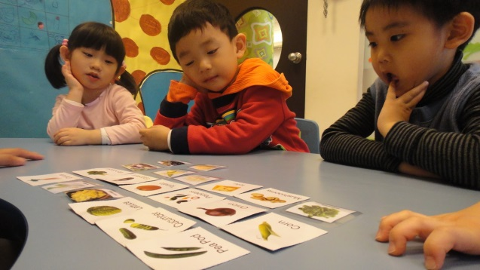
It is vital that daily routines and times are organised to give children the opportunity to develop their play and in turn their learning.
These routines, as with planning, should be flexible and reactive to children’s changing needs.
Children should be given ample opportunity to conclude their play, whilst being made aware of transition periods.

Guidance on use of observation, assessment and planning documents

All About Me
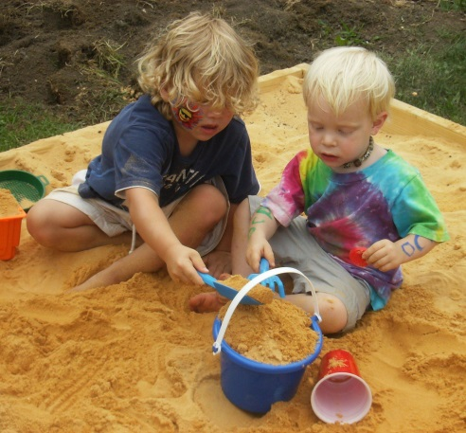
This should be completed alongside parents prior to children’s’ entry to the setting, generally during settling in sessions. This will include all key information on children to give practitioners an understanding of each child’s needs, likes and interests. (Please see template included.)

EYFS guide for parents
This provides parents with a brief and easily accessible understanding of the Early Years Foundation Stage and how their child will learn and progress. It is also designed to promote partnership working and to help the transition between learning in the setting, and learning at home. (Please see template included.)

Baseline
A baseline assessment should be completed as a child starts the setting, to provide an initial basis for planning and on-going progress. This should be completed by incorporating input from parents, the beginnings of the observation process and practitioners developing knowledge of each child. This can be completed on the child’s individual tracking document.

Planning for individual interests and next steps
Planning should always take account of both children’s developmental needs and their ever-changing interests in equal measure. This can be achieved through both individualised planning, as well as group planning at various times. Children’s next steps should be effectively incorporated into both planned activities and also enhancements made to the provision, enabling a number of relevant learning opportunities. (Please see template included.)

Observations/Photographs
Observations should be carried out as required, in relation to a child’s developmental milestones being attained. These should be objective – just describing exactly what the child is doing. The assessment of these will then form the basis for the child’s next steps, progressing learning effectively. There should be a balance between snapshot observations- brief recordings of children‘s engagement in activities- as well as more in-depth observations- linked more closely into individual children’s next steps. . (Please see template included.)

EYFS Tracking
Children’s progress needs to be collated and tracked to not only inform planning, but to highlight areas to develop and to identify any gaps in learning. This then provides an on-going record of children’s development and is tracked via development matters statements. (Please see template included.)
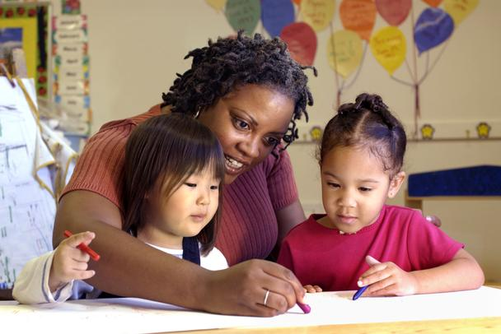
Summative Assessment
This assessment tool collates children’s developmental data and summarises on-going progress at regular intervals. Generally it is considered good practice to carry summative assessments out as a minimum termly with both child and parental input. (Please see template included.)

Cohort Tracking
This brings all children’s developmental data together, allowing settings to report on specific cohorts of children. This information can highlight specific groups of children who are overachieving / underachieving and will feed in settings improvement plans. Analysing developmental data in this way allows key points and areas for improvement to be focused on in a continual cycle.

Two Year Progress Check
This is a statutory requirement and should be completed when a child is between 24 and 30 months old. The two year progress check involves a summary of children’s development in the three prime areas. (Please see template included.)

Integrated Review
The integrated review brings together information from parents, a child key worker and link health professional. This creates a more rounded view of children’s development between the ages of two/two and a half as it combines a range of viewpoints in one integrated approach. For more information on the integrated review please contact the Quality Improvement and Business Support Team at fis@wirral.gov.uk or telephone 606 3980

