Local Offer Wirral – Update
Service Level Outcomes
Service level Outcomes – Outcomes to be achieved through the development:
- Create an attractive and accessible local offer site
- Increase the awareness of SEND reforms and Local Offer
- Children, young people & their carers and their families have better access to local services as well as early years, schools and colleges and other providers.
- Children & young people & their carers and families have increased opportunities to shape Wirral’s Local Offer
Outputs
- Explore website feedback satisfaction survey in first 6 months
- Number of visits to the website
- Inform local commissioning
- Number of organisations registered
- The Site
- The Local Offer Wirral site went live on Friday 29th August in time for the September 1st, 2014 deadline.
2. We are continuing to work with key stakeholders including parents regarding content and copy to feature under the six main categories on the site plus the various sub categories under each of the main headings.
3. Following the recent legislative training we have developed a list of areas that may need revisiting on the Local Offer site. These have been sent to Peter Davies 06.11.14 and he will take these points directly to the SEN Managers meeting on 12th November.

- Categories that we need content/copy for are detailed below. Please view by clicking here www.localofferwirral.org
Category Sub Sections
Health Health Provision
Within Health: We have removed the age tabs as per Katy Coxhead’s request and added the words ‘Content coming soon’.
We attended the EHC Health Steering Group meeting this morning (27.11.14) and have produced guidance and offered support to members of the group regarding the provision of service and information data for the site.
Info & Support Resources
(Has been removed. Family Forum originally offered to develop this ‘By parents for parents’, awaiting invitation to proceed).
Housing Taken from Council site
Personal Budgeting Awaiting Social Care Personal Budget info Check

Transition
This section would perhaps benefit from someone looking at it again and adding more to the intro paragraph.
Independent Living Taken from Code of Practice
Preparing for Adulthood Taken from Council site
Early Years to Primary
Primary Education to Secondary
Secondary Education to Post-16

2. SERVICES REGISTERED
We have invited over 1000 organisations to register their services on the Local Offer site.
To date we have 237 services registered including Education settings featured on the Local Offer site (up from 71 at last count 09.09.2014).
We have written to Education settings inviting them to ‘Claim Ownership’ of their listing on the site, 44 settings have now done this (9 at last report 09.09.2014).
(For a Breakdown of Services Registered in each category. Please see Appendices 1 for list of registered services).
We are continuing to invite local services to register, providing a helpline and are working on a daily basis to maintain and enhance the site in terms of content and functionality.

3. FEEDBACK ‘Have Your Say’

The ‘Have Your Say’ page asks users to provide any feedback that they may have relating to the site. Whenever a user provides feedback using the online form we are sent an email with their comments. Currently gathers feedback regarding the site. (Please see Appendix 2 for online feedback).
We are currently developing a service specification for a feedback mechanism and associated costs to design and ‘turn-on’ a bespoke, version of the ‘trip-advisor’ style rating system of services that is built in to the system that will exclude education settings.

4. Co-Production
Please see Appendix 3 for feedback from parents.
5. Weekly Analytics
We measure insights relating to traffic to the site, this includes site and page visits, which pages on the site are the most popular and how long users are spending on each page on the site.
When considering this outcome it is important to realise that without any promotion of the site, both service registrations and the number of the visits will be effected.

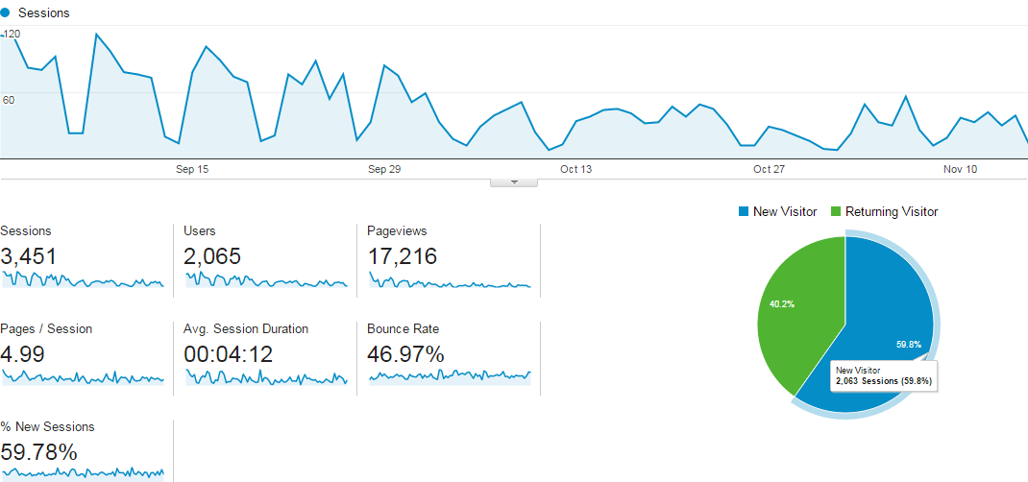

Weekly Search Keywords
We measure the most popular search terms and which keywords are returning no results.
Below is a list of the top search keywords from 11/11 – 16/11
6. Podio
We have developed and customised an online Project Management Suite called Podio which is updated on a daily basis. This allows us to monitor the nature and frequency of enquiries that we are receiving by email, phone and face-to-face. We are also monitoring provision of content for the site (including who sent it, when and where we were asked to locate it within the site).
7. Increase the awareness of SEND Reforms and Local Offer
We have submitted an outline and costs for promoting the Local Offer.

APPENDICES
Listings by category

Listings by Name
Co-Production Notes
Enquiries/Feedback regarding site and content

