 |  |  |  |  | Children and Young People’s Department  Julia Hassall  Director  Hamilton Building,  Conway Street,  Birkenhead,  Wirral  CH41 4FD
to | Headteachers/ SENCO’s |  |  | date | 05.09.16
my ref | MM
service | Specialist Services
tel | 0151 666 4297 | Please ask for | Mrs. M. Morris
fax | 0151 666 4690
email | margaretmorris@wirral.gov.uk

Dear Colleagues,

I trust that you have all had a well-earned break and enjoyed the summer holidays.

Prior to schools breaking up in July the SEND department distributed Threshold Documents that outlined a description of need for each area identified in the Code of Practice and the evidence required by the LA for consideration for additional support for the CYP. Following feedback these have been amended and the final versions are now attached. They all have 09.16 on to avoid confusion. The documentation relates to

- MLD/CLD
- ASC
- MPN
- HI
- VI
- SEMH
- SpLD

In addition you will find attached four documents. These are

- Applying for a Pupil Funding Agreement (guidelines on the information to be submitted)
- Application Form for a Pupil Funding Agreement
- Applying for an Education, Health and Care Needs Assessment (guidelines on the information to be submitted)
- Application Form for an Education, Health and Care Needs Assessment.

With the new documentation, the Additional Support Plan should no longer be submitted. We have linked the new request forms to the threshold documents. However, an Additional Support Plan or similar should be used to support CYP in schools, prior to them requiring additional support from the LA. All documentation should be submitted to the LA electronically.

Cathy O’Connor has written to schools outlining the arrangements for E.P allocation. In the initial meetings with schools, headteachers/ SENCO’s should discuss the needs of children/ young people outlining where a consultative piece will be required. Following the completion of this piece of work schools will receive the report within 15 working days. In many cases reports should be with you sooner but this allows for any statutory work which has to take priority. With the number of requests for statutory assessments growing it adds an additional pressure on the Service. The number of requests for 15-16 was 249 compared with 197 during 14-15.This rise of 62 obviously impacted upon the consultative work being carried out. There are two posts agreed and once the recommendations from the Review of the Support Services have been approved the Service will be shaped to meet the needs of CYP in settings, schools and colleges. The publication of the Review has been delayed as a result of the two elections and the LA Ofsted Safeguarding Inspection. In the interim Cathy and I should be kept informed of any concerns so that we can address them.

We are aware of the amount of information the LA has produced in relation to SEND. We are producing an SEND Handbook to collate all the documentation together. This will be with you by the October half term.

The Toolkits that relate to the Threshold documents will be distributed to schools by the 19th September.

All the documents will be on the Local Offer.

Yours sincerely,
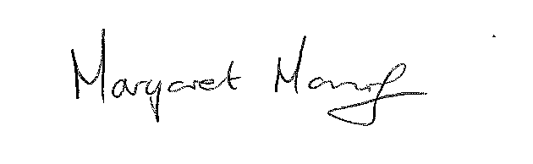
Margaret Morris
Interim Senior Manager SEND

